**Deccan Education Society’s**

**Navinchandra Mehta Institute of Technology and Development**

# C E R T I F I C A T E

This is to certify that Mr. **Pranay Chandu Giradkar** of M.C.A. Semester III with Roll No. **C22041** has completed **_All_** practicals of **MCAL35 Software Testing And Quality Assurance Lab** under my supervision in this college during the year 2022-2023.

|  |  |  |  |  |  |
| --- | --- | --- | --- | --- | --- |
| CO | R1  (Attendance) | R2  (Performance during lab session) | R3  (Innovation in problem solving technique) | R4  (Mock  Viva) | R5  (Variation in implementation of learnt topics on projects) |
| CO1 |  |  |  |  |  |
| CO2 |  |  |  |  |  |
| CO3 |  |  |  |  |  |
| CO4 |  |  |  |  |  |

Practical-in-charge Head of Department

MCA Department

(NMITD)

|  |  |  |  |  |
| --- | --- | --- | --- | --- |
| **MCAL35 Software Testing and Quality Assurance Lab Index** | | | | |
| **Sr.**  **No.** | **Topic Name** | **Date** | **CO** | **Sign** |
| **Manual Testing** | | | | |
| **1.** | **Implementation of Black Box Testing**  Prepare test cases for below given applications using Boundary Value Analysis and Equivalence Class Partitioning   1. BMI Calculator:   Input: Person’s Weight and Height Output: Body Mass Index  The range of Weight : 3 kg to 300 kg  The range of Height : 0.3 meter to 2.4 meter   1. Triangle Problem :   Triangle Problem accepts three integers – a, b, c as three sides of  the triangle. It returns the type of triangle (Scalene, Isosceles, Equilateral, Not a Triangle) formed by a, b, c. |  | **CO1** |  |
| **2.** | **Implementation of White Box Testing**  Data Flow Analysis, Control Flow Analysis, Cyclomatic Complexity |  | **CO1** |  |
| **3.** | 1. Prepare test cases on ATM Machin using Unit and System Testing 2. Prepare a test cases on Login Page of Gmail using Unit and System Testing 3. Prepare a test cases on Calculator using Unit and System   Testing |  | **CO1** |  |
| **Automation Testing** | | | | |
| **4.** | **Introduction to Selenium**   1. Write down a steps and process of Selenium IDE Installation on any 1 browser.(eg.Firefox) 2. Record and run test cases on demotour website for login page through Mozila Firefox. 3. Record and run test cases on demotour website for login page through Google Chrome. 4. Record and run test cases on Registration form of any website 5. Record and run test cases on any website to check the validations of elements. (eg. IRCTC , MSRTC , etc ) |  | **CO2** |  |
| **5** | Implement **Web Drivers** on Chrome & Firefox Browsers. |  | **CO2** |  |
| **6** | Demonstrate handling multiple frames in selenium |  | **CO2** |  |
| **7** | Implement Browser command and navigation Commands. |  | **CO2** |  |
| **8** | Implement the find element command |  | **CO2** |  |
| **9** | Demonstrate the Locator(id,css selector, path) |  | **CO2** |  |

|  |  |  |  |  |
| --- | --- | --- | --- | --- |
| **10** | Demonstrate different types of alerts |  | **CO2** |  |
| **11** | Demonstrate :   * Handling Drop Down, * List Boxes * Command Button, * Radio buttons & text boxes. * Waits command in selenium |  | **CO2** |  |
| **12** | Installation of TestNg , running testNg |  | **CO3** |  |
| **13** | TestNg annotations |  | **CO3** |  |
| **14** | Demonstrate Validation testing |  | **CO4** |  |
| **15** | Perform regression testing |  | **CO4** |  |

# 2. Implementation of White Box Testing

use,

# Data Flow Analysis

* Statements where variables receive values,
* Statements where these values are used or referenced.
* A variable is defined but not used or referenced,
* A variable is used but never defined,
* A variable is defined twice before it is used
* To find a variable that is used but never defined,
* To find a variable that is defined but never used,
* To find a variable that is defined multiple times before it is
* Deallocating a variable before it is used.
* Time consuming and costly process
* Requires knowledge of programming languages

**Data Flow Testing** is a type of structural testing. It is a method that is used to find the test paths of a program according to the locations of definitions and uses of variables in the program. It has nothing to do with data flow diagrams.

It is concerned with:

If a statement is a loop or if condition then its DEF set is empty and USE set is based on the condition of statement s.

Data Flow Testing uses the control flow graph to find the situations that can interrupt the flow of the program.

Reference or define anomalies in the flow of the data are detected at the time of associations between values and variables. These anomalies are:

**Advantages of Data Flow Testing:**

Data Flow Testing is used to find the following issues-

**Disadvantages of Data Flow Testing Example:**

* 1. **read x, y;**
  2. if(x>y) **3.** a = x+1 else

**4. a = y-1**

**5. print a;**

**Control flow graph of above example:**

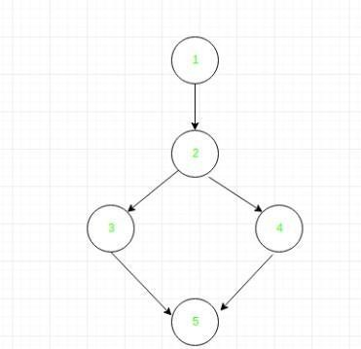

**Define/use of variables of above example:**

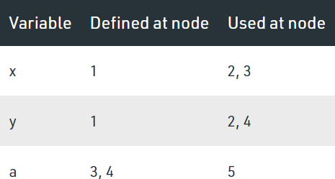

# Control Flow Analysis

-Control flow testing uses the control structure of the program to develop the test cases for the program.

-The test cases are developed to sufficiently cover the whole structure of the program.

-The control structure of a program can be represented by the control flow graph of the program.

# Control Flow Graph:

int evensum(int i)

{

int sum=0; while (i<=10)

{

if(i/2==0) sum=sum+i; i++;

}

return sum;

}

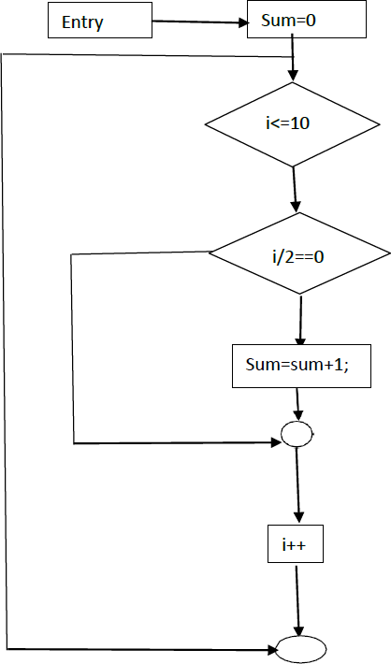

# Statement Converge = (Total number of executed Statement) * 100

**Total no of Statement**

# Cyclomatic Complexity

If A=354

Then If B > C Then A = B Else A = C

End If Print A

**Method 1:**

Cyclomatic Complexity = Total number of Closed regions in the + 1

=2+1

=3

**Method 2:**

Cyclomatic complexity = E-N+2, E= Edges and N= Nodes

=8-7+2

=3

**Method 3:**

Cyclomatic Complexity = P + 1

=2+1

=3

# 3. Test cases

1. **Prepare test cases on ATM Machin using Unit and SystemTesting**

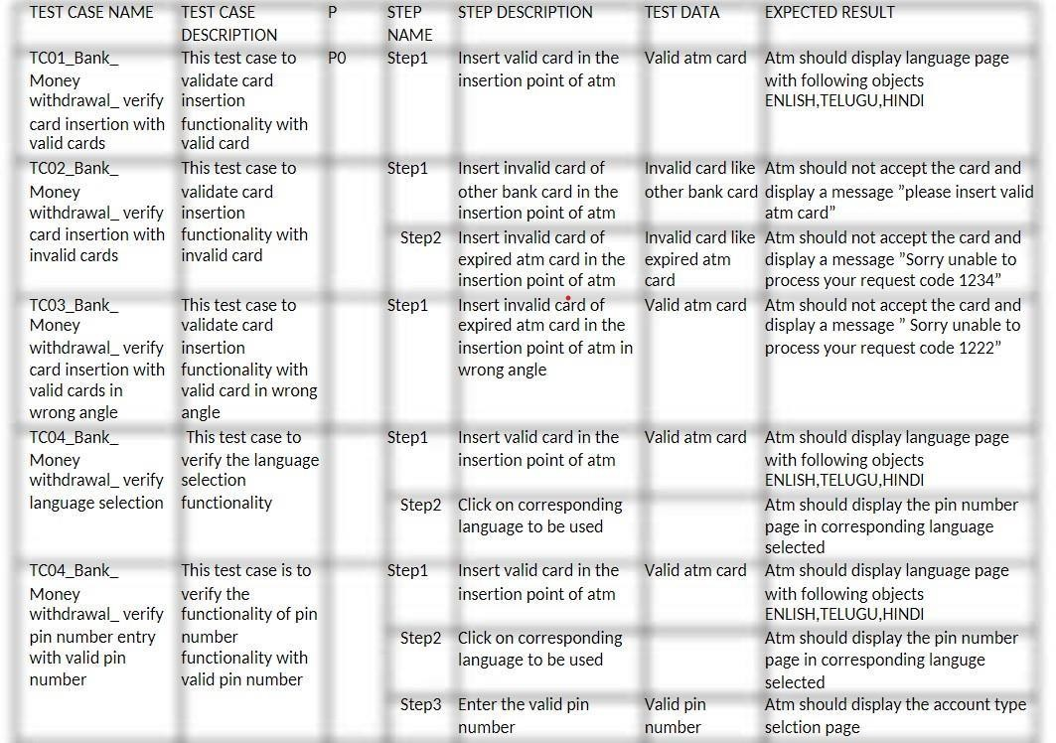

# Prepare a test cases on Login Page of Gmail using Unit andSystem Testing

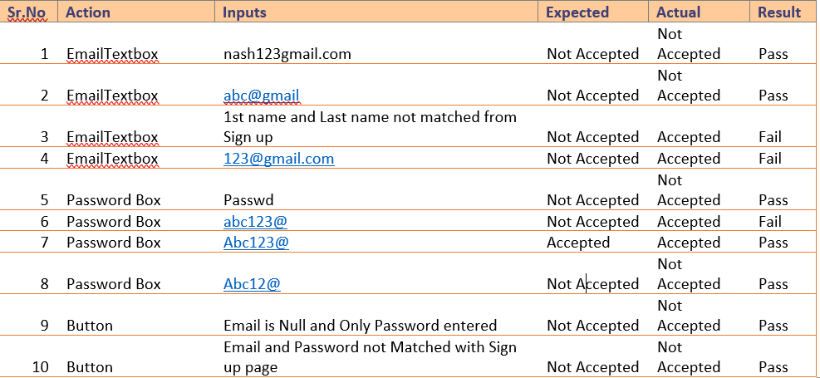

1. **Prepare a test case on Calculator using Unit and System Testing**

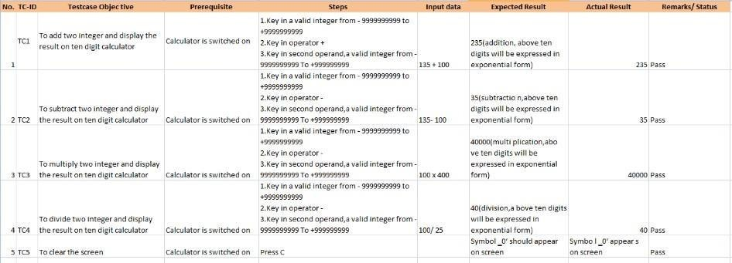

# Introduction to Selenium:

1. **Write down a steps and process of Selenium IDE Installationon any 1 browser (eg.Firefox).**

Installation in Goolge Chrome:

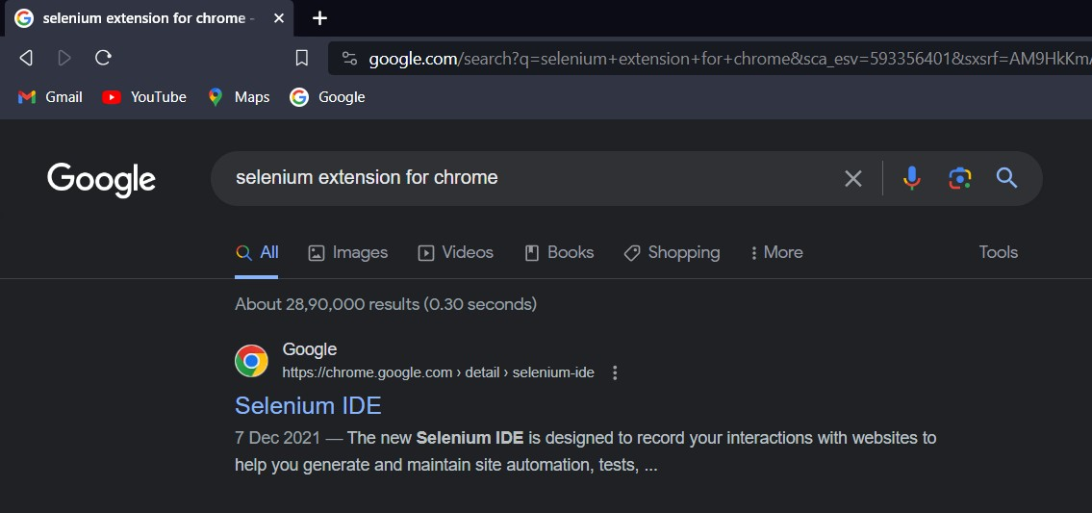Step1: Search on Google chrome for “selenium extension for chrome”

Step 2: click on add to chrome:

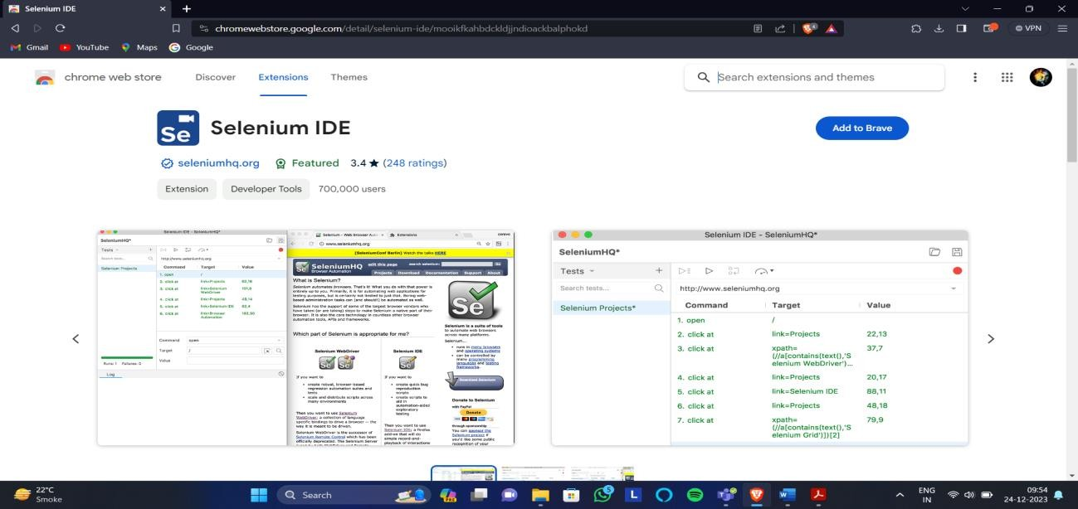

Step : Click on Add to Chrome

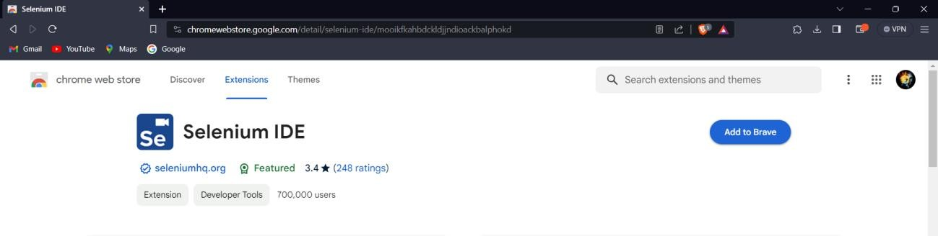

Step 4: Click on Add Extension

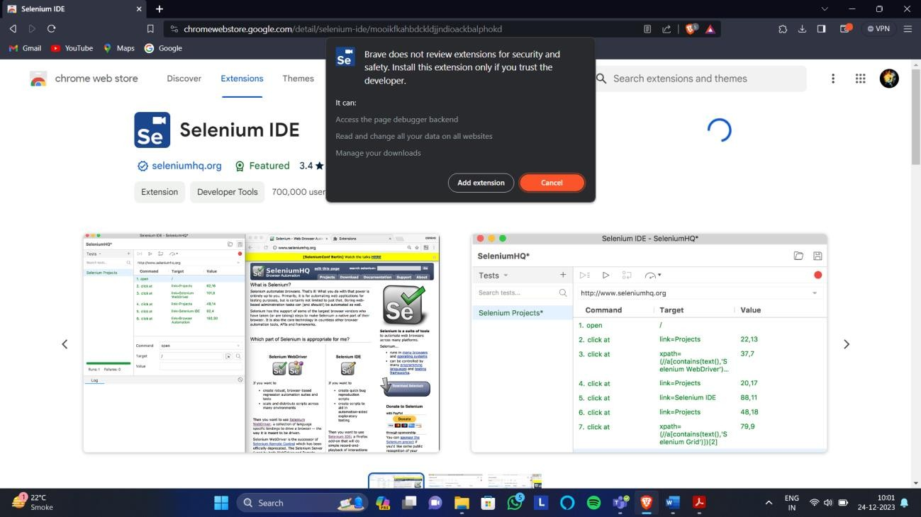

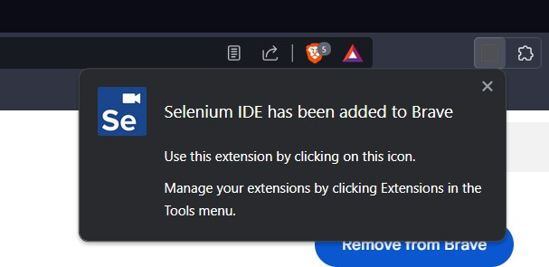Step 5: Installation Done and the following pop-up will be shown

Step 6: To open Selenium in Chrome, Click on Following

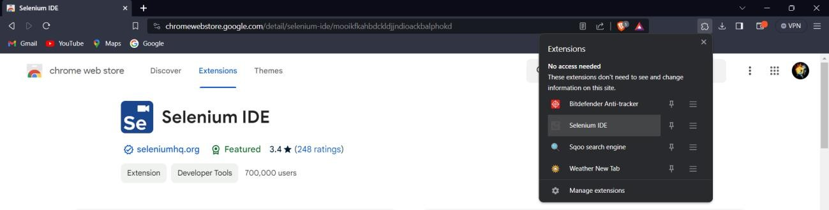

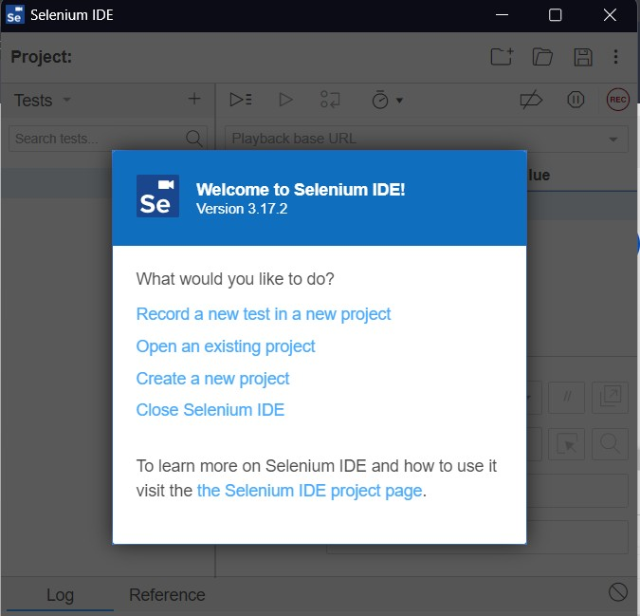Step 7: Selenium Window will open

# Record and run test cases on demotour website for login pagethrough Mozila Firefox.

Case1: Both username and password are incorrect

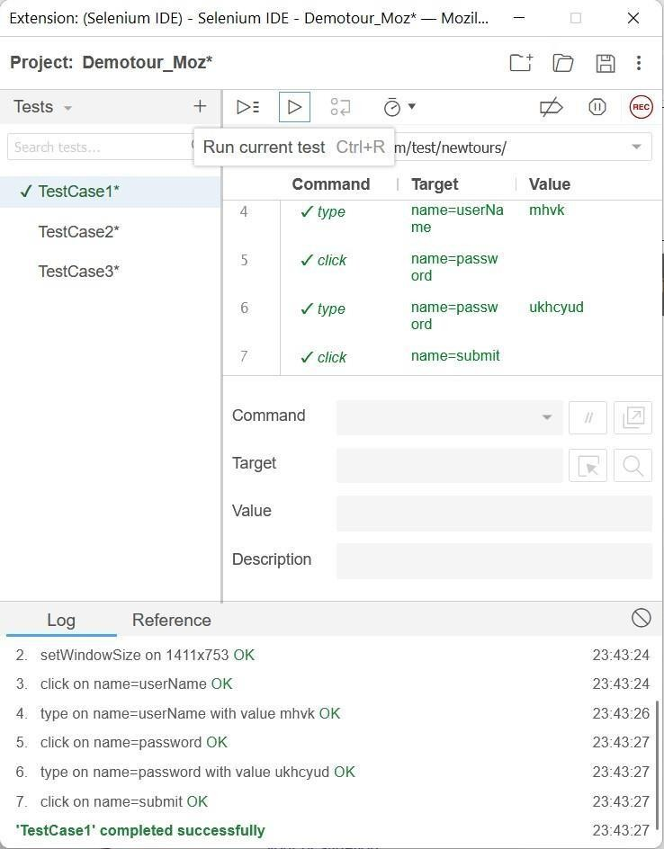

Case2: Username is correct but password is incorrect

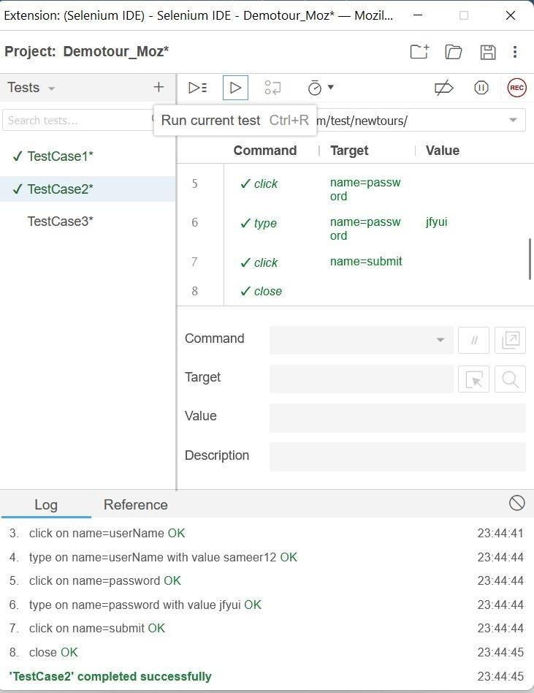

Case3: Username is incorrect but password is correct

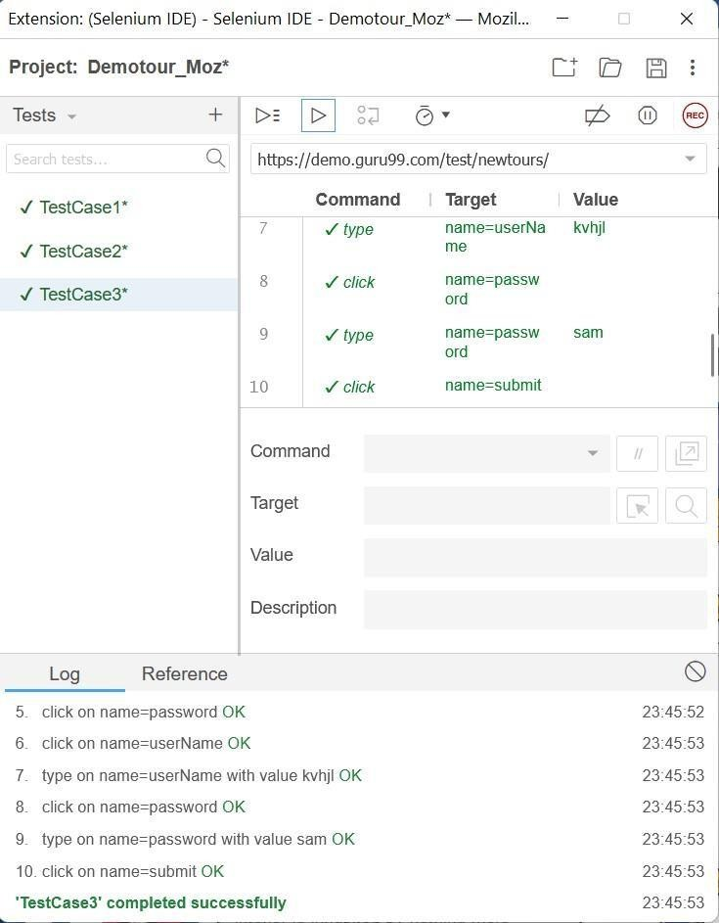

Case 4: Both Username and Password are correct

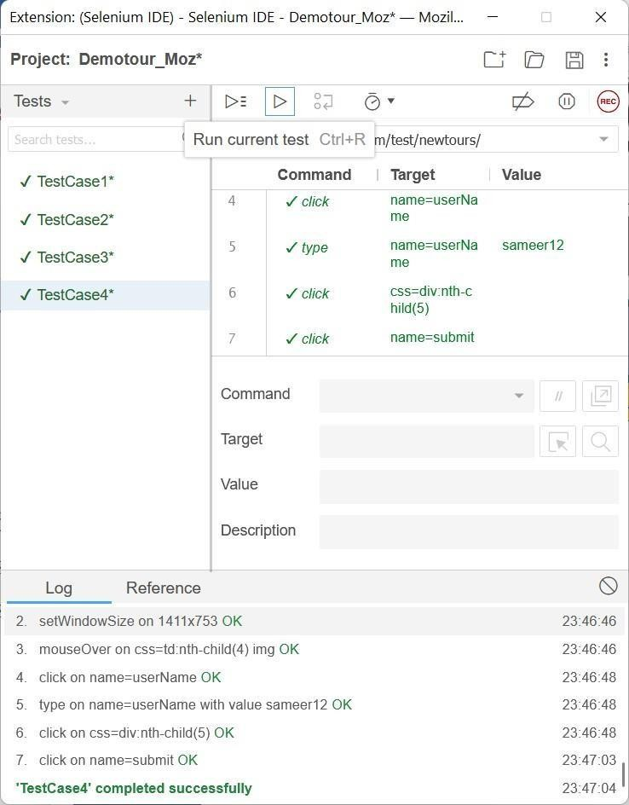

# Record and run test cases on demotour website for login pagethrough Google Chrome.

Step 1: Click on new Project and give the project name

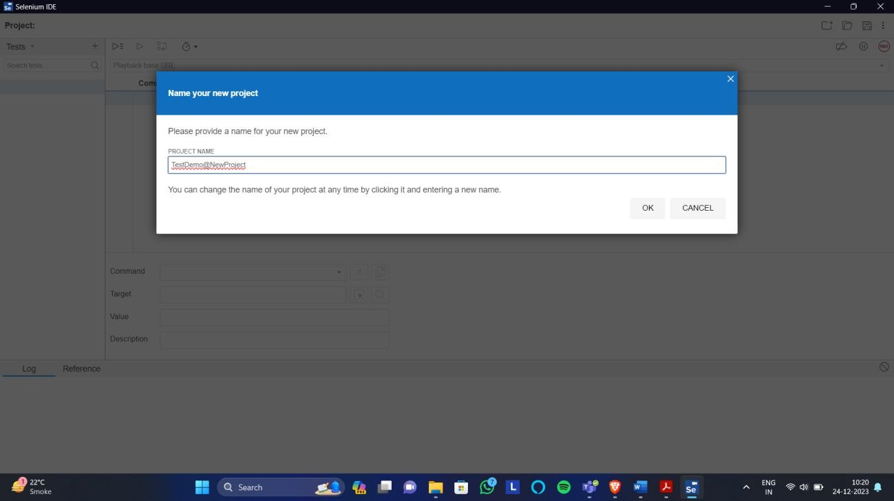

Step 2: Paste the demotour website Link(<https://demo.guru99.com/test/newtours/>) asShown and Click on Rec

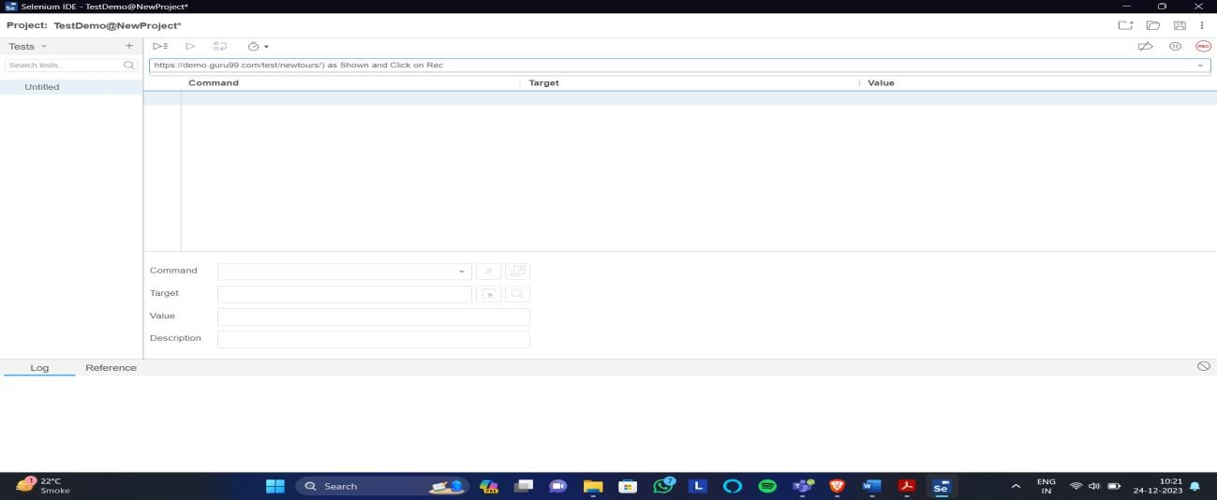

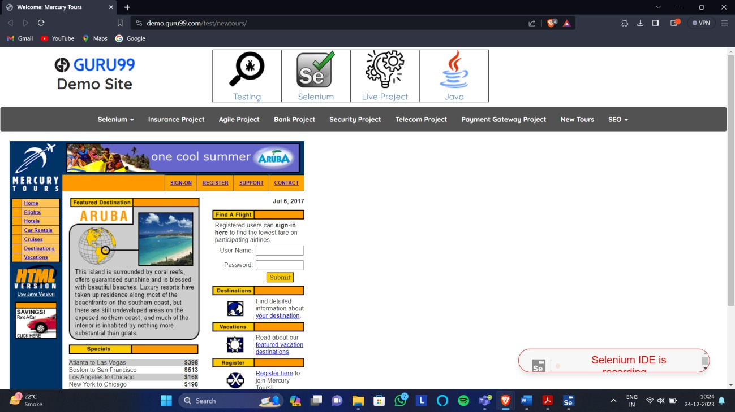Step 3: New window will open maximise that window

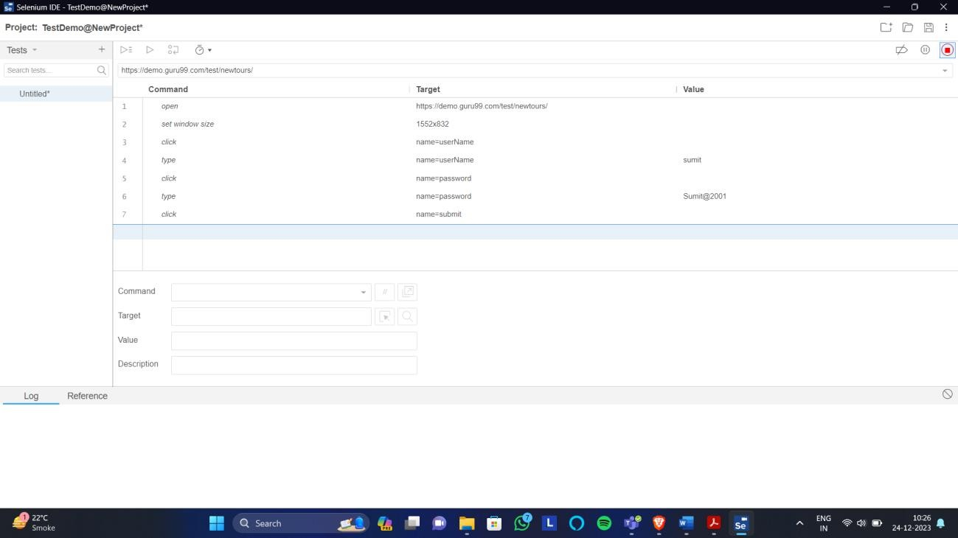First Test Case: Both the username and password is incorrect

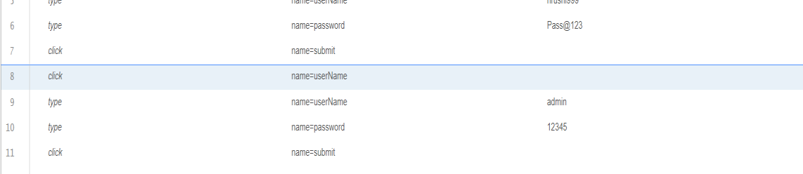

Second Test Case: Username is correct but Password is incorrect

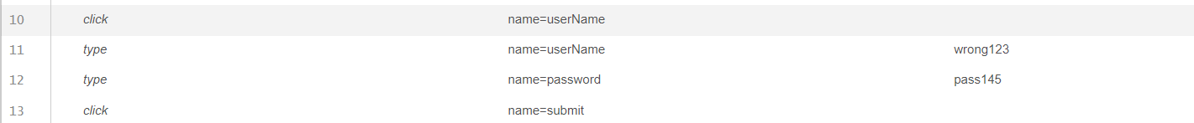Third test Case: Username is incorrect but Password is correct

Fourth Test Case: Both Username and password is Correct



# Record and run test cases on Registration form of any website

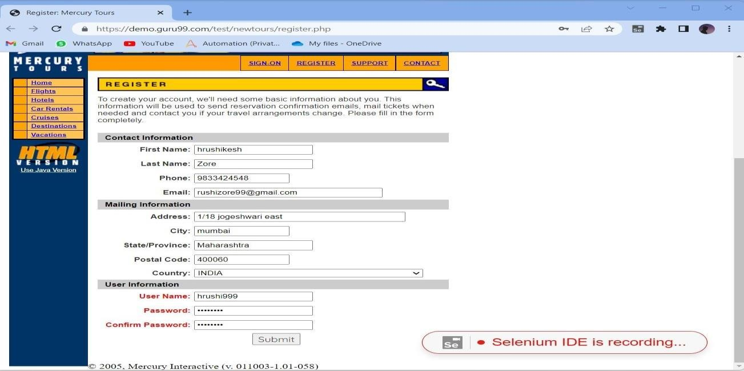

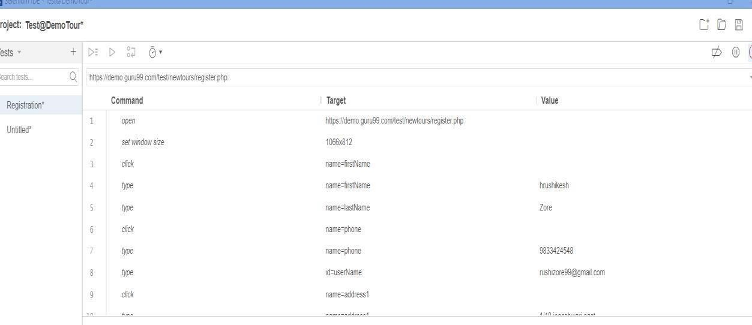

1. **Record and run test cases on any website to check thevalidations of elements. (eg. IRCTC, MSRTC, etc):**

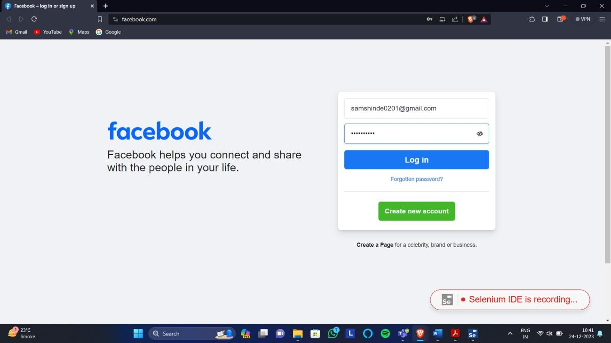TestCase1: facebook Username and password incorrect

TestCase2: Gmail

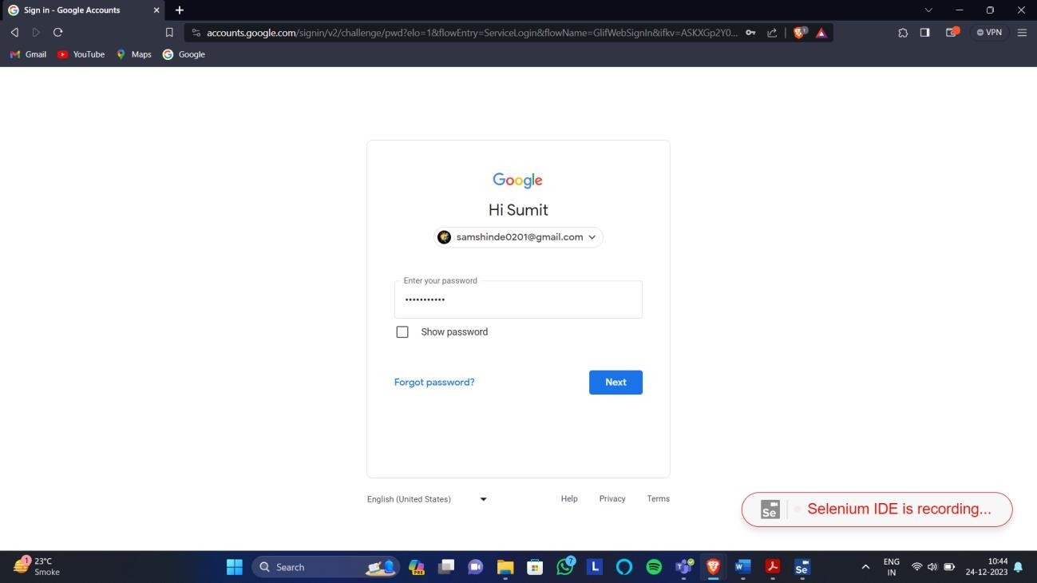

# Implement Web Drivers on Chrome & Firefox Browsers.

WebDriver in Chrome:

Installation Steps:

Step 1: Check the version of Chrome

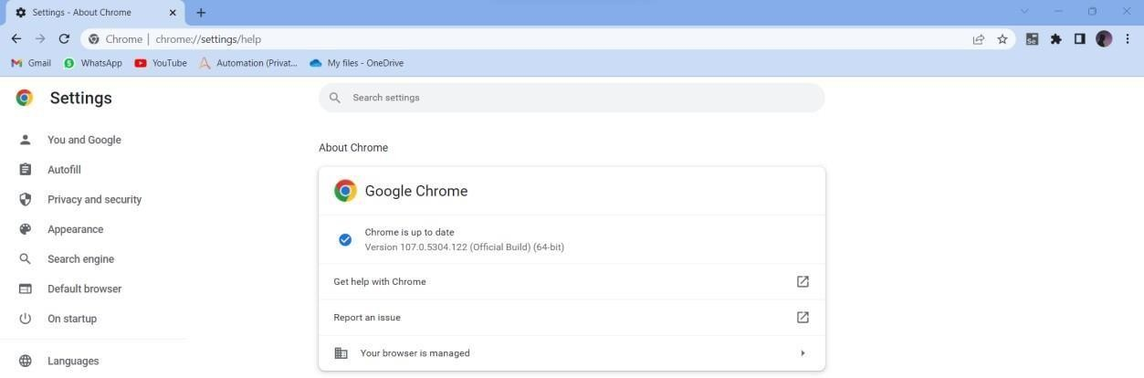

Step2: Search for the Driver in google by giving command “selenium driver forchrome”

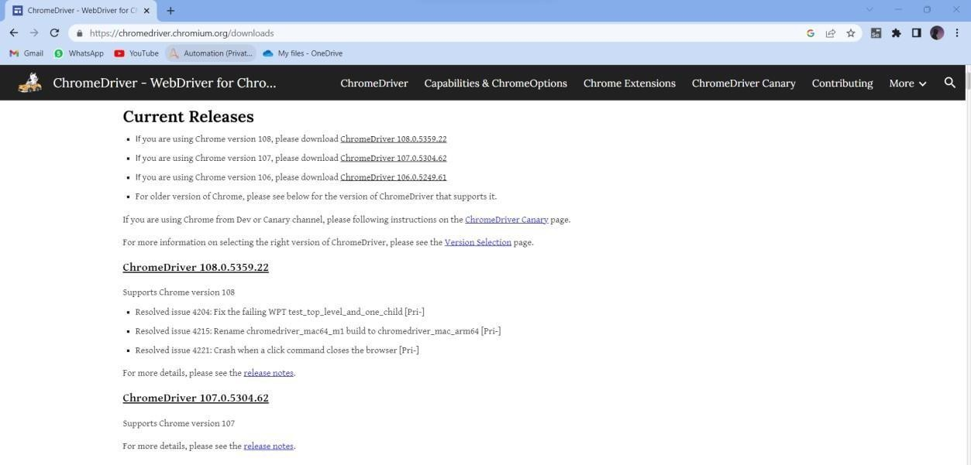

Step3: Click on Respective version and Download the zip file and Create the Separatefolder of the name driver and extract the zip file in that folder

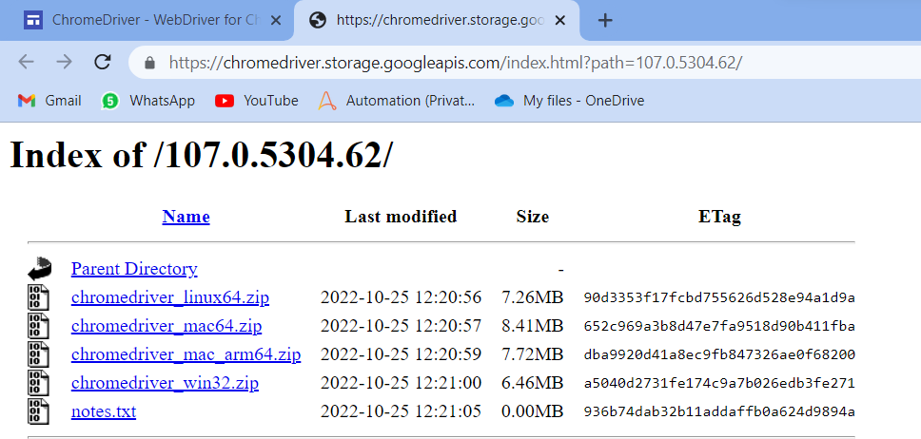

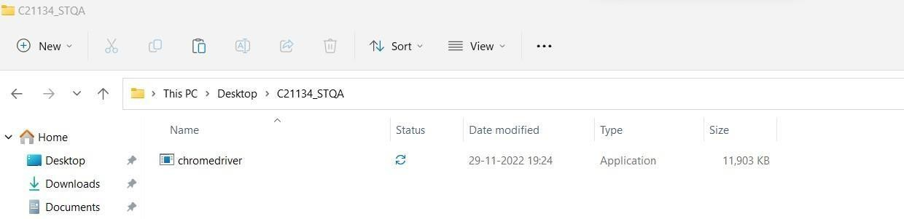

Step 4: Download the jar file by typing the following query “selenium jar files download” ,Zip file will be downloaded extract the zip file in the Separate dedicated folder.

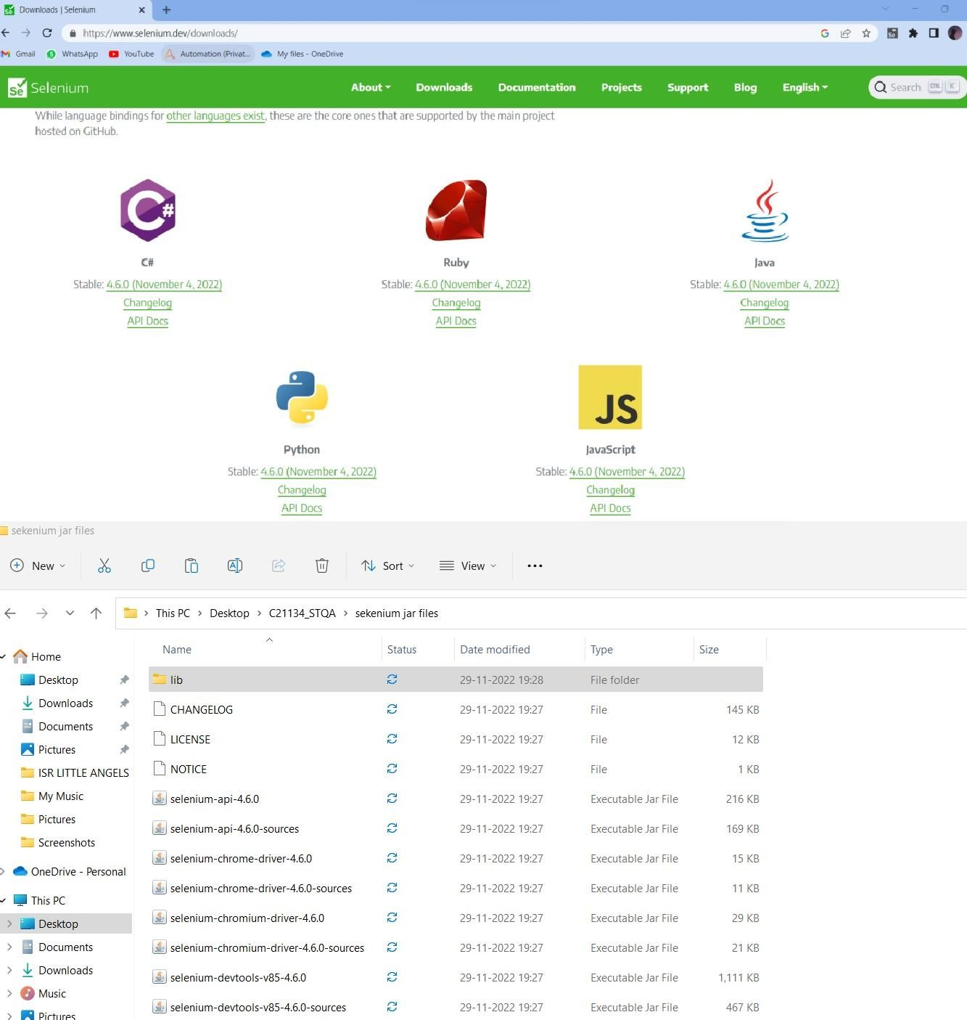

Step 5: Install Eclipse if not there

Step 6: Open Eclipse and create a java Project, give the project name, Creat a package in thatProject Give a package name, Create a Class give a name to the class

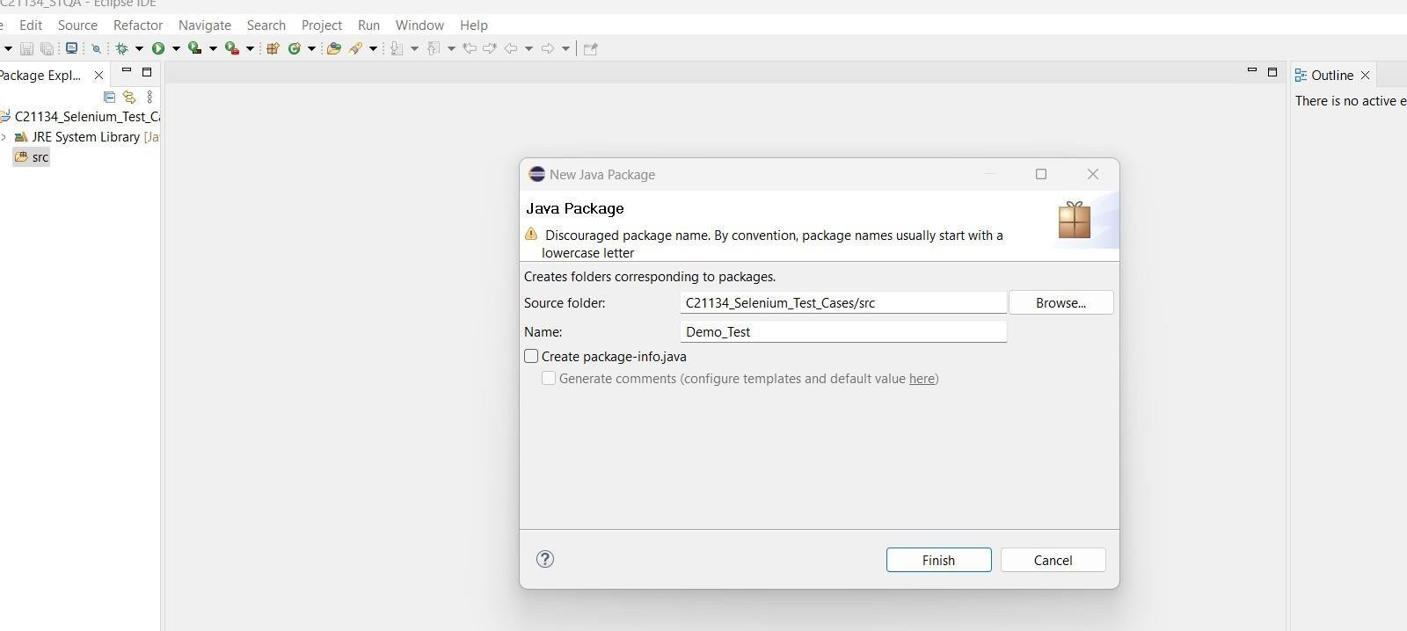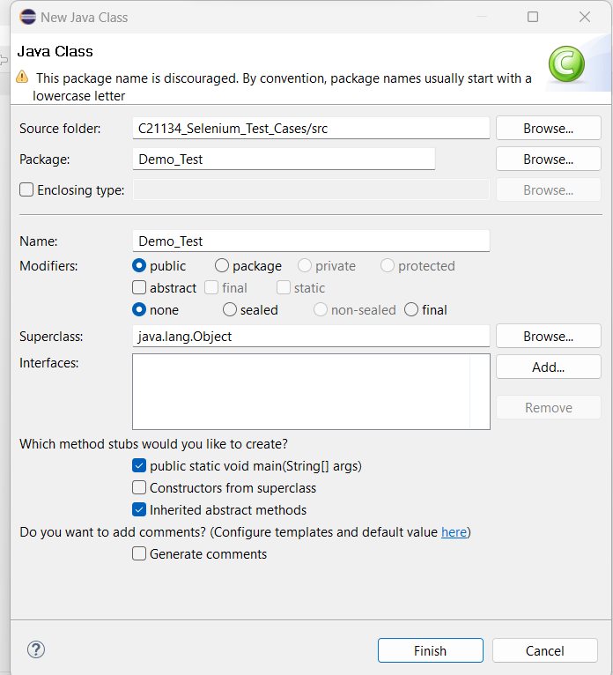

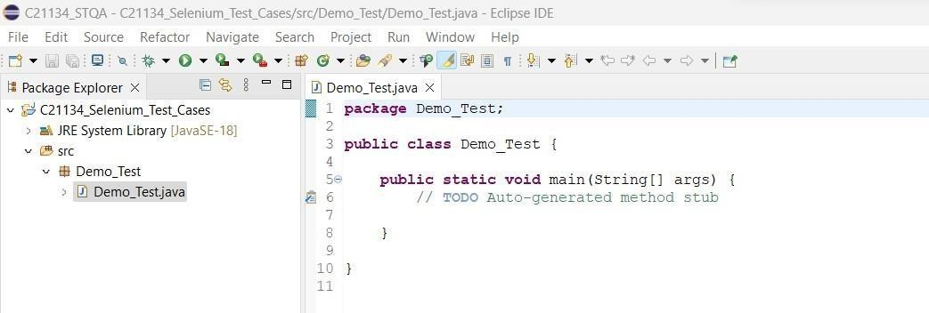

Step7: Import the jar file of selenium in eclipse, Right click on project goto properties, Gotojava build path, Goto Libraries, Click on Classpath , Click on add External jar

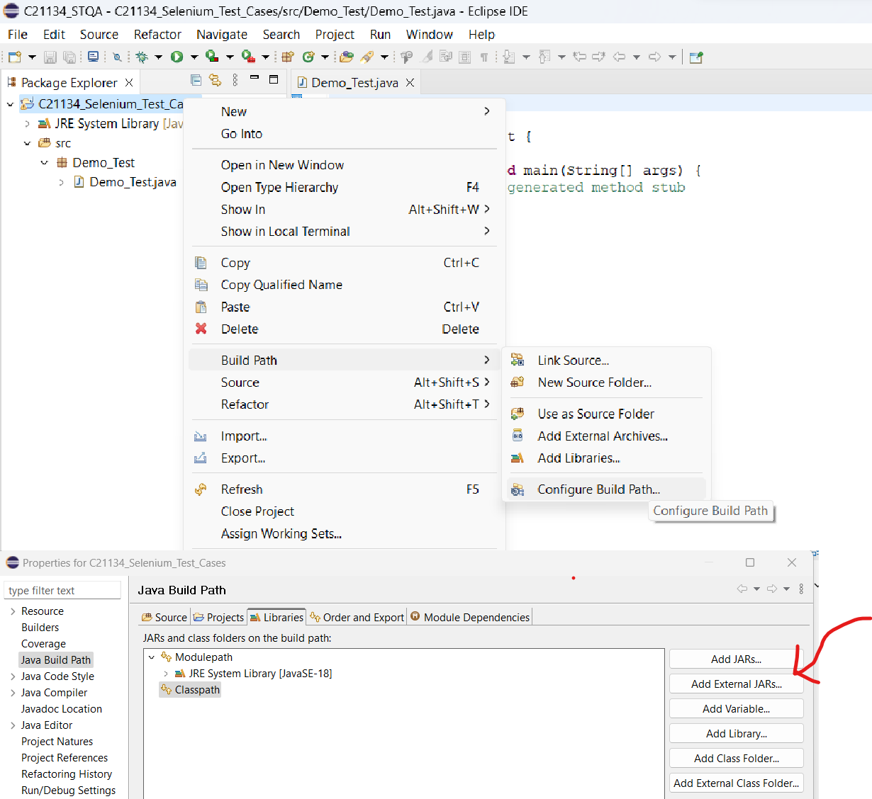

Step 8: Select all the jar files inside of lib folder too

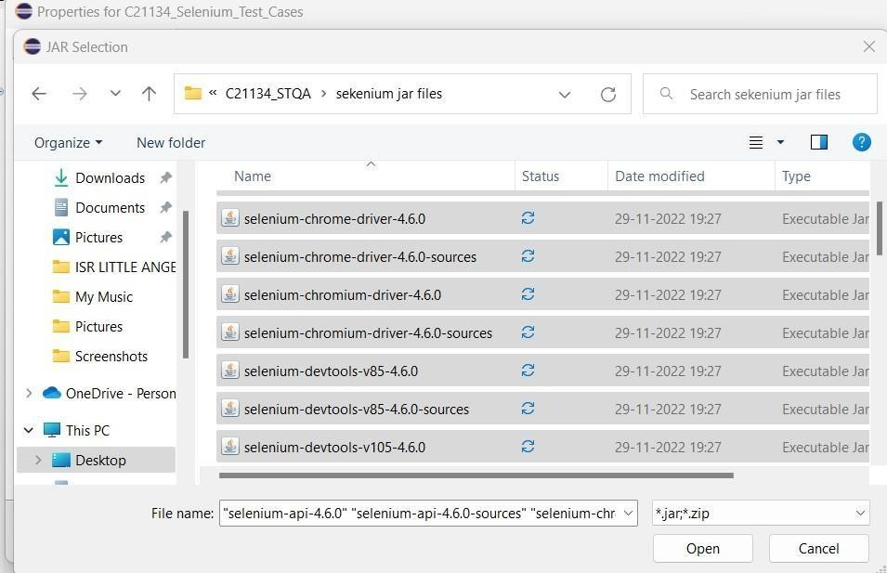

Step 9: Setup is ready know check the basic program for driverCode:

package TestCases;

import org.openqa.selenium.WebDriver;

import org.openqa.selenium.chrome.ChromeDriver; public class First_Test

{

public static void main(String[] args)

{

System.setProperty("Webdriver.chrome.driver","C:\\Users\\rushi\\On eDrive\\Desktop\\C21134_STQA\\chromedriver.exe"

}

}

Output :

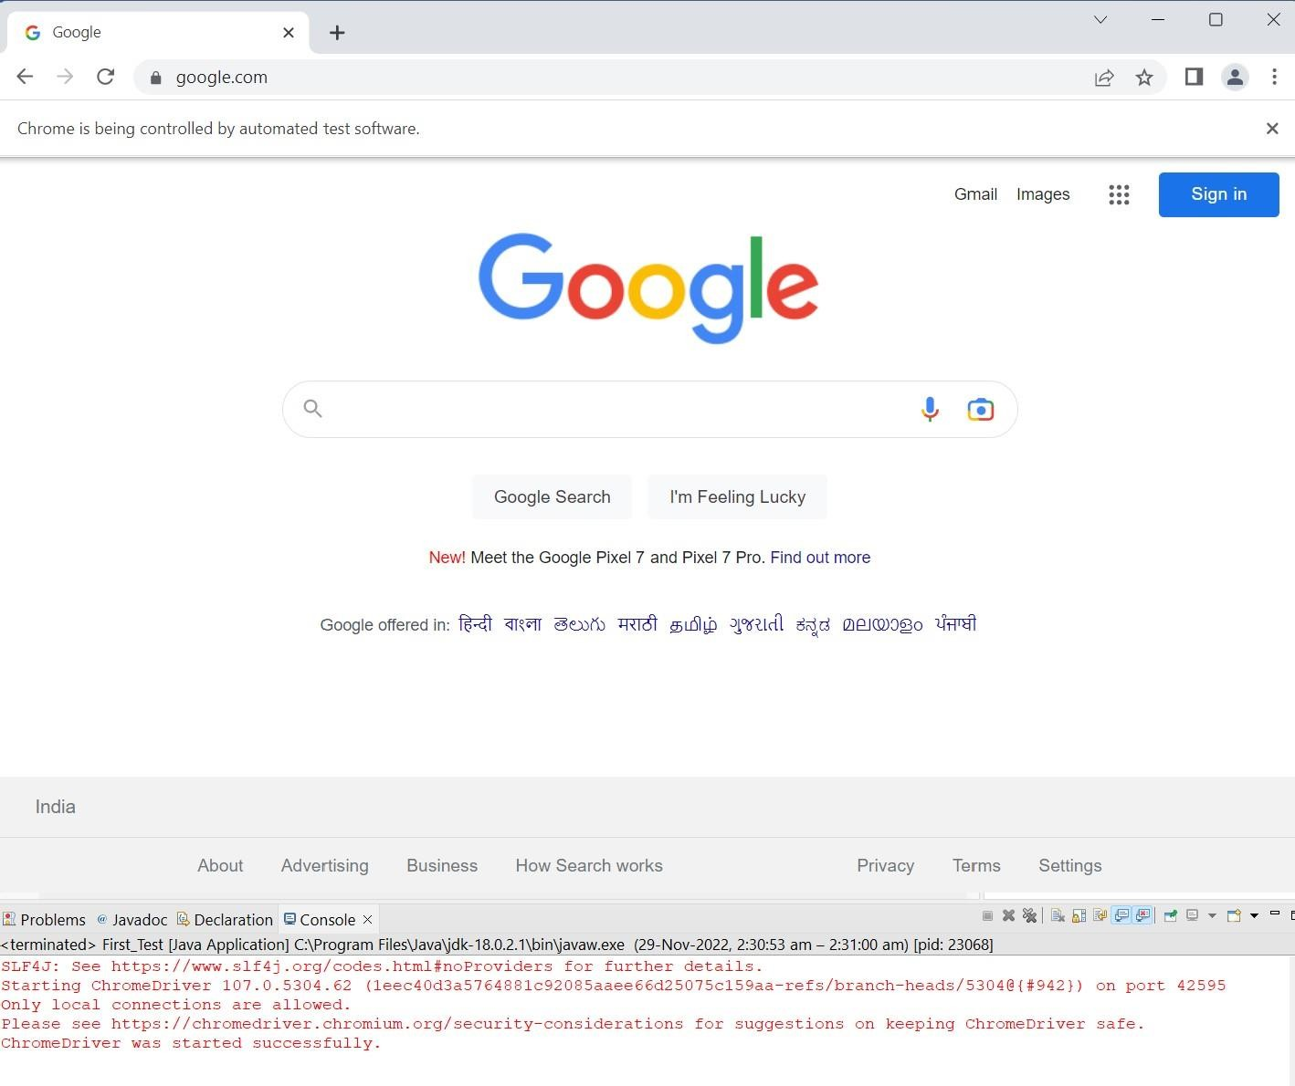

# WebDriver in Firefox:

Step 1. the zip file of diver click on link <https://github.com/mozilla/geckodriver/releases>and download it and Extract the zip file and save it to the Divers folder

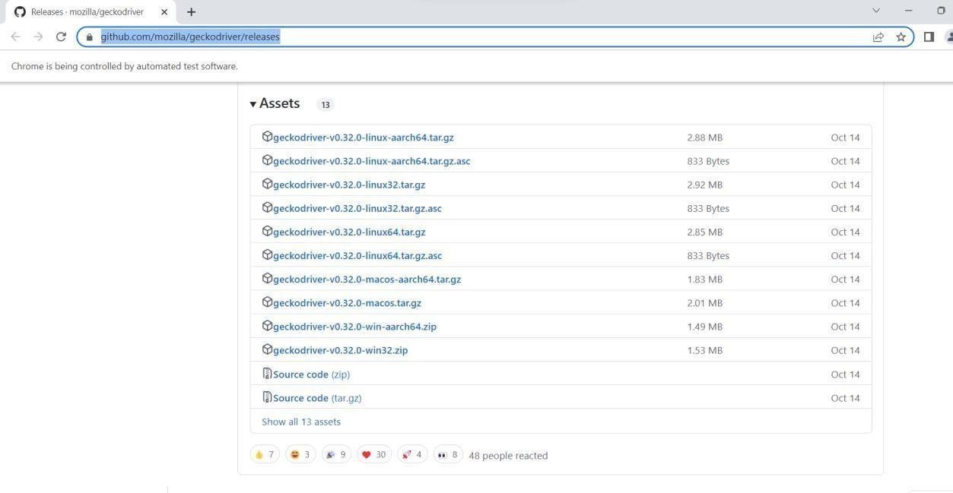

Repeat the same steps from step 4 to step 8

Step 9: Setup is ready know check the basic program for driver package TestCases;

import org.openqa.selenium.WebDriver;

import org.openqa.selenium.firefox.FirefoxDriver; public class Fire_1

{

public static void main(String[] args)

{

System.setProperty("Webdriver.gecko.driver", "C:\\STQA\\Drivers\\geckodriver.exe");

WebDriver driver = new FirefoxDriver();

driver.get("https://[www.google.com/"](http://www.google.com/)); String title = driver.getTitle(); System.out.println("The title is "+title);

}

}

Output :

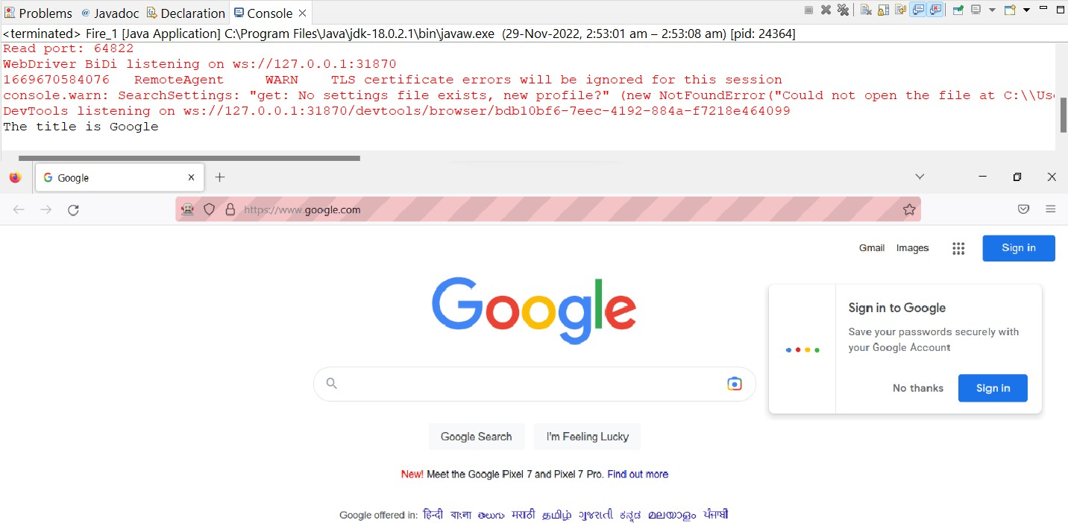

# Demonstrate handling multiple frames in selenium

Code:

package TestCases;

import org.openqa.selenium.By;

import org.openqa.selenium.WebDriver;

import org.openqa.selenium.chrome.ChromeDriver; public class Multi_Frames

{

public static void main(String[] args)

{

System.setProperty("Webdriver.chrome.driver","C:\\Users\\rushi\\On eDrive\\Desktop\\C21134_STQA

\\chromedriver.exe");

WebDriver driver = new ChromeDriver(); driver.get("[http://demo.guru99.com/test/guru99home/"](http://demo.guru99.com/test/guru99home/));

// navigates to the page consisting an iframe

driver.manage().window().maximize(); driver.switchTo().frame("a077aa5e");

System.out.println("We are switch to the iframe"); driver.findElement(By.xpath("html/body/a/img")).click();

//Clicks the iframe System.out.println("*We are done*");

}

}

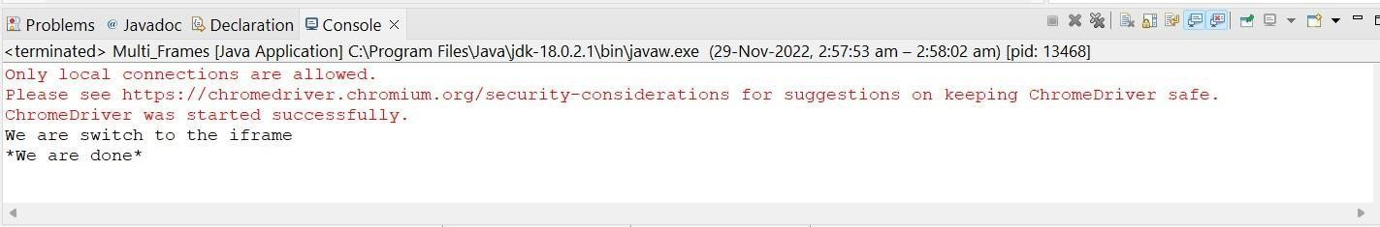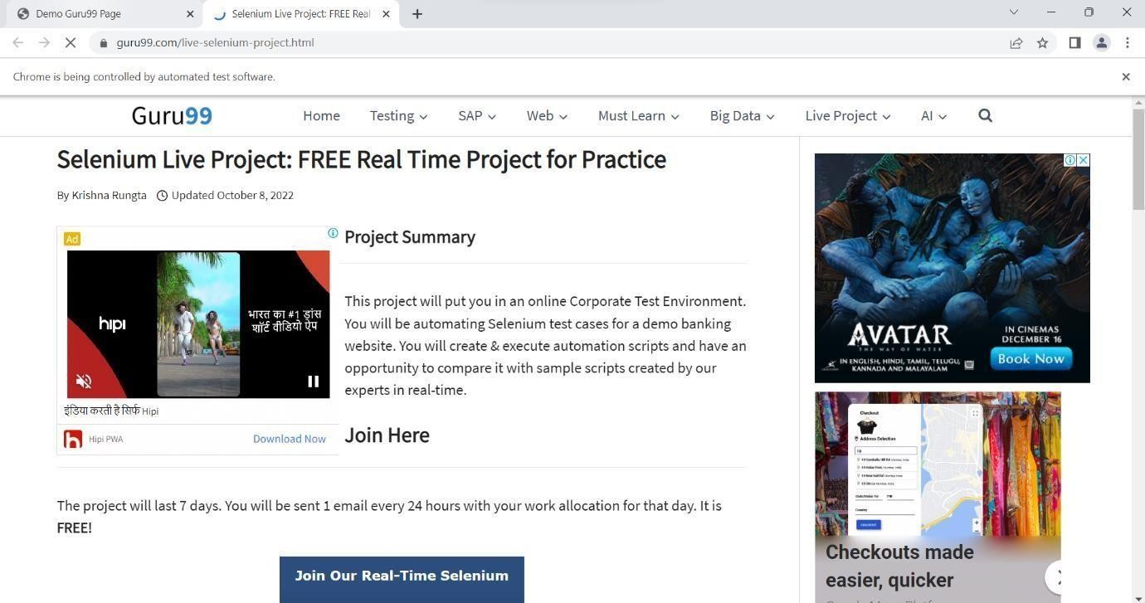**Output:**

# Implement Browser command and navigation Commands. Code:

package TestCases;

import org.openqa.selenium.By;

import org.openqa.selenium.WebDriver;

import org.openqa.selenium.chrome.ChromeDriver; public class Navigation {

public static void main(String[] args) { System.setProperty("Webdriver.chrome.driver","C:\\Users\\rushi\\On eDrive\\Desktop\\C21134_STQA

\\chromedriver.exe");

WebDriver driver = new ChromeDriver();

//driver.get("https://[www.google.com](http://www.google.com/)"); driver.navigate().to("https://[www.google.com](http://www.google.com/)"); driver.findElement(By.linkText("Images")).click(); try {

Thread.sleep(2000);

} catch (InterruptedException e) {

// TODO Auto-generated catch block e.printStackTrace();

}

driver.navigate().back(); try { Thread.sleep(1000);

} catch (InterruptedException e) {

// TODO Auto-generated catch block e.printStackTrace();

}

System.out.println("back done "); driver.navigate().forward();

try { Thread.sleep(1000);

} catch (InterruptedException e) {

// TODO Auto-generated catch block e.printStackTrace();

}

System.out.println("Forward done. "); driver.navigate().refresh();

try { Thread.sleep(1000);

} catch (InterruptedException e) {

// TODO Auto-generated catch block e.printStackTrace();

}

System.out.println("refresh done. ");

}

**Output:**

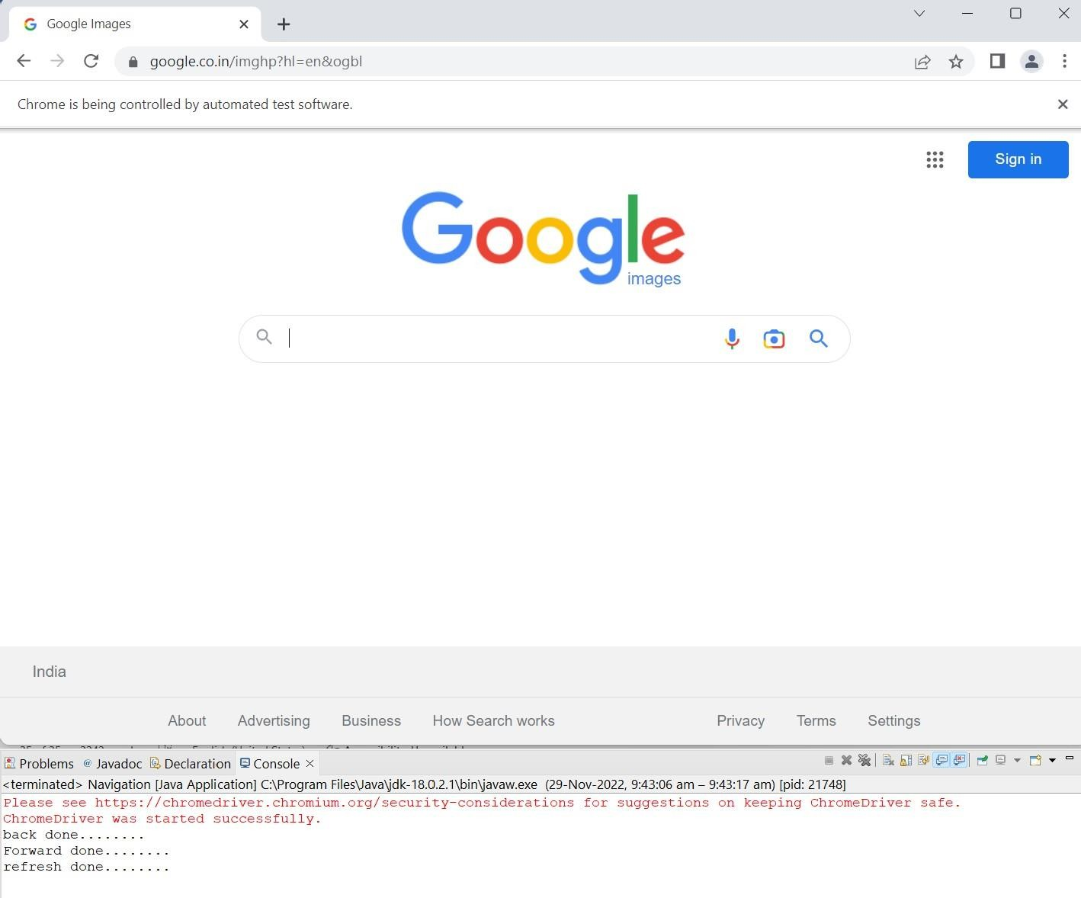

1. **Implement the find element command**

Code:

package TestCases;

import org.openqa.selenium.By;

import org.openqa.selenium.WebDriver; import org.openqa.selenium.WebElement;

import org.openqa.selenium.chrome.ChromeDriver; public class Find_Element {

public static void main(String[] args) { System.setProperty("Webdriver.chrome.driver","C:\\Users\\rushi\\On eDrive\\Desktop\\C21134_STQA

\\chromedriver.exe");

WebDriver driver = new ChromeDriver();

//driver.get("https://[www.google.com](http://www.google.com/)"); driver.navigate().to("https://[www.facebook.com/"](http://www.facebook.com/)); WebElement el = driver.findElement(By.id("email")); el.sendKeys("[hanchatesameer@gmail.com](mailto:hanchatesameer@gmail.com)"); WebElement el2 = driver.findElement(By.id("pass")); el2.sendKeys("123456");

WebElement el3 = driver.findElement(By.name("login")); el3.click(); System.out.println("Login button clicked");

}

}

**Output:**

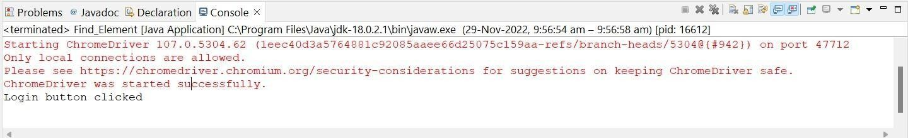

Forgotten password? Link button testing By Find Element: Code: package TestCases;

import org.openqa.selenium.By;

import org.openqa.selenium.WebDriver; import org.openqa.selenium.WebElement;

import org.openqa.selenium.chrome.ChromeDriver; import org.openqa.selenium.firefox.FirefoxDriver; public class FindElemnt2 {

public static void main(String[] args) { System.setProperty("Webdriver.chrome.driver","C:\\Users\\rushi\\On eDrive\\Desktop\\C21134_STQA

\\chromedriver.exe");

WebDriver driver = new FirefoxDriver();

//driver.get("https://[www.google.com](http://www.google.com/)"); driver.navigate().to("https:/[/www.facebook.com/"](http://www.facebook.com/));

WebElement el = driver.findElement(By.linkText("Forgotten password?")); el.click();

System.out.println("Forgoten password? Clicked");

}

}

Output:

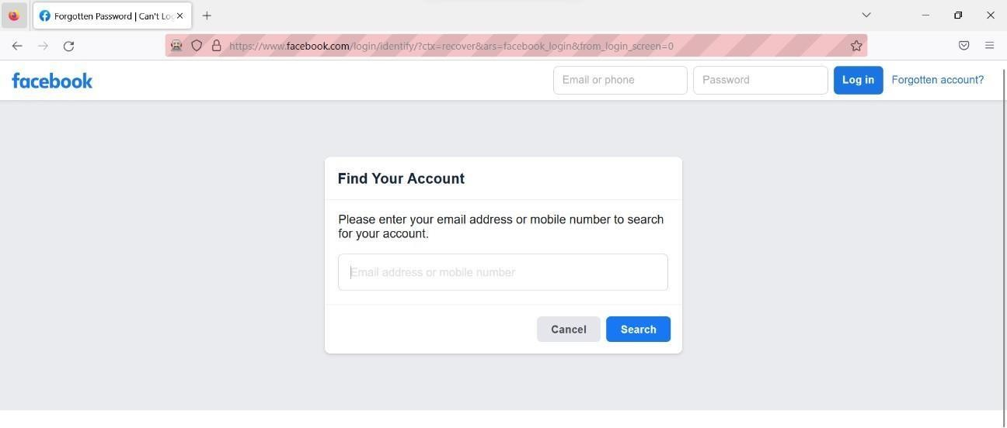

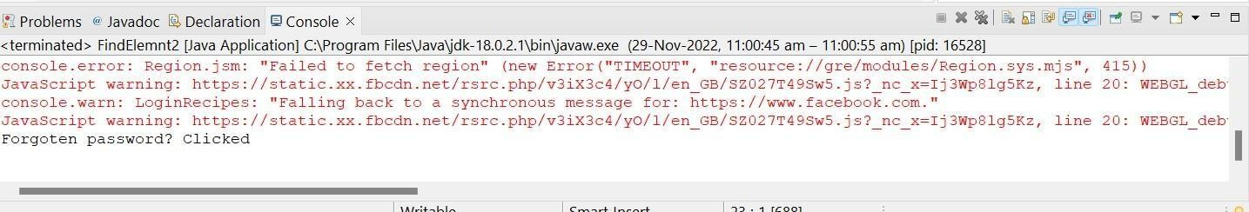

To Get the URL and Title:

Code:

package TestCases;

import org.openqa.selenium.WebDriver;

import org.openqa.selenium.chrome.ChromeDriver; public class URL_Title {

public static void main(String[] args) { System.setProperty("Webdriver.chrome.driver","C:\\Users\\rushi\\On eDrive\\Desktop\\C21134_STQA

\\chromedriver.exe");

WebDriver driver = new ChromeDriver();

//driver.get("https://[www.google.com](http://www.google.com/)"); driver.navigate().to("https://[www.facebook.com/"](http://www.facebook.com/)); System.out.println(driver.getTitle()); System.out.println(driver.getCurrentUrl());

}

}

Output:

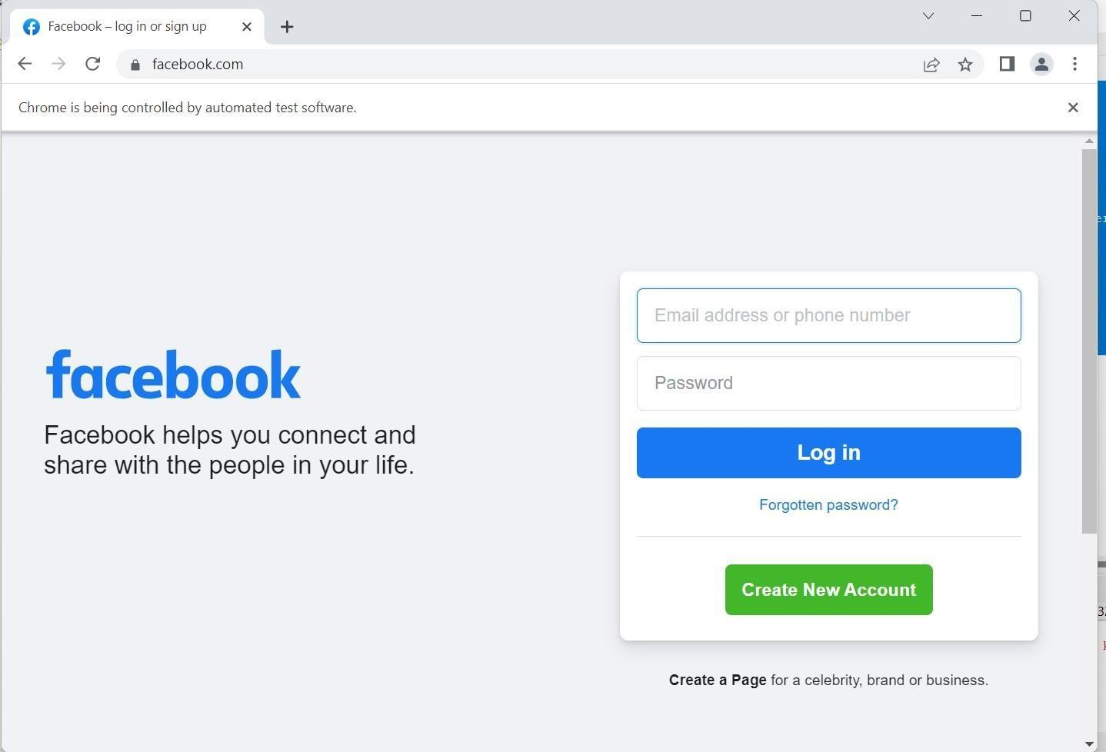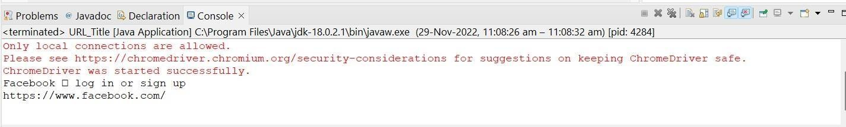

To Test Attributes and Tag name:

Code:

package TestCases;

import org.openqa.selenium.By;

import org.openqa.selenium.WebDriver; import org.openqa.selenium.WebElement;

import org.openqa.selenium.chrome.ChromeDriver; public class Tag_Name {

public static void main(String[] args) { System.setProperty("Webdriver.chrome.driver","C:\\Users\\rushi\\On eDrive\\Desktop\\C21134_STQA

\\chromedriver.exe");

WebDriver driver = new ChromeDriver();

//driver.get("https://[www.google.com](http://www.google.com/)"); driver.navigate().to("https://[www.facebook.com/"](http://www.facebook.com/)); String title = driver.getTitle(); System.out.println("Title is : "+title);

WebElement el = driver.findElement(By.id("email")); System.out.println(el.getAttribute("class")); System.out.println(el.getTagName());

}

}

Output:

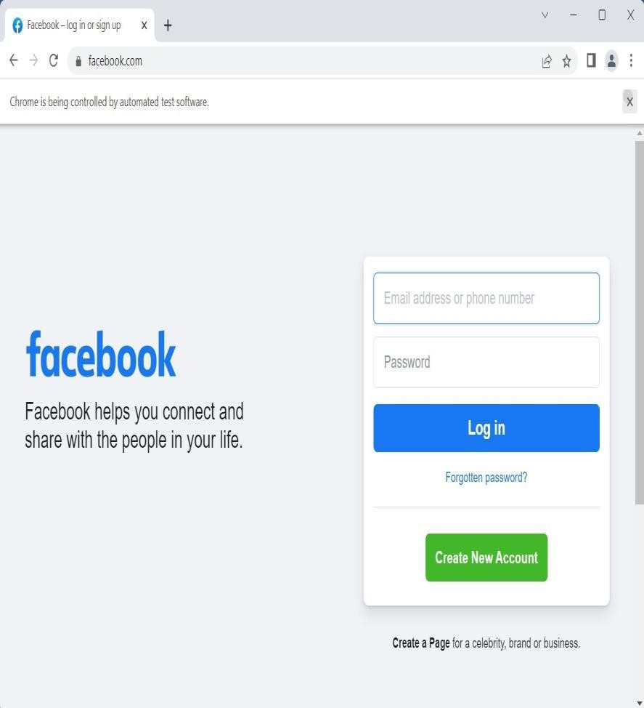

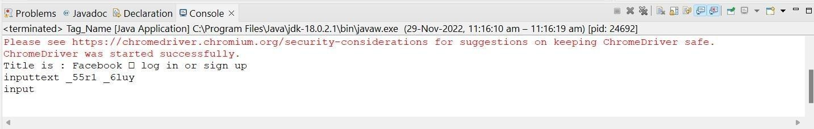

# Demonstrate the Locator (id, CSS selector, path)

XPath Locator:

Code:

package TestCases;

import org.openqa.selenium.By;

import org.openqa.selenium.WebDriver; import org.openqa.selenium.WebElement;

import org.openqa.selenium.chrome.ChromeDriver; public class Locators {

public static void main(String[] args) {

System.setProperty("Webdriver.chrome.driver","C:\\Users\\rushi\\On eDrive\\Desktop\\C21134_STQA

\\chromedriver.exe");

WebDriver driver = new ChromeDriver(); driver.get("https://[www.facebook.com/"](http://www.facebook.com/));

WebElement img = driver.findElement(By.xpath("//*[@id=\"email\"]")); System.out.println(img.isDisplayed()); System.out.println(img.isEnabled()); System.out.println(img.isSelected());

}

}

System.setProperty("Webdriver.chrome.driver","C:\\Users\\rushi\\On eDrive\\Desktop\\C21134_STQA

\\chromedriver.exe");

WebDriver driver = new ChromeDriver(); driver.get("https://[www.facebook.com/"](http://www.facebook.com/));

WebElement img = driver.findElement(By.xpath("//*[@id=\"email\"]")); System.out.println(img.isDisplayed()); System.out.println(img.isEnabled()); System.out.println(img.isSelected());

}

}

Output:

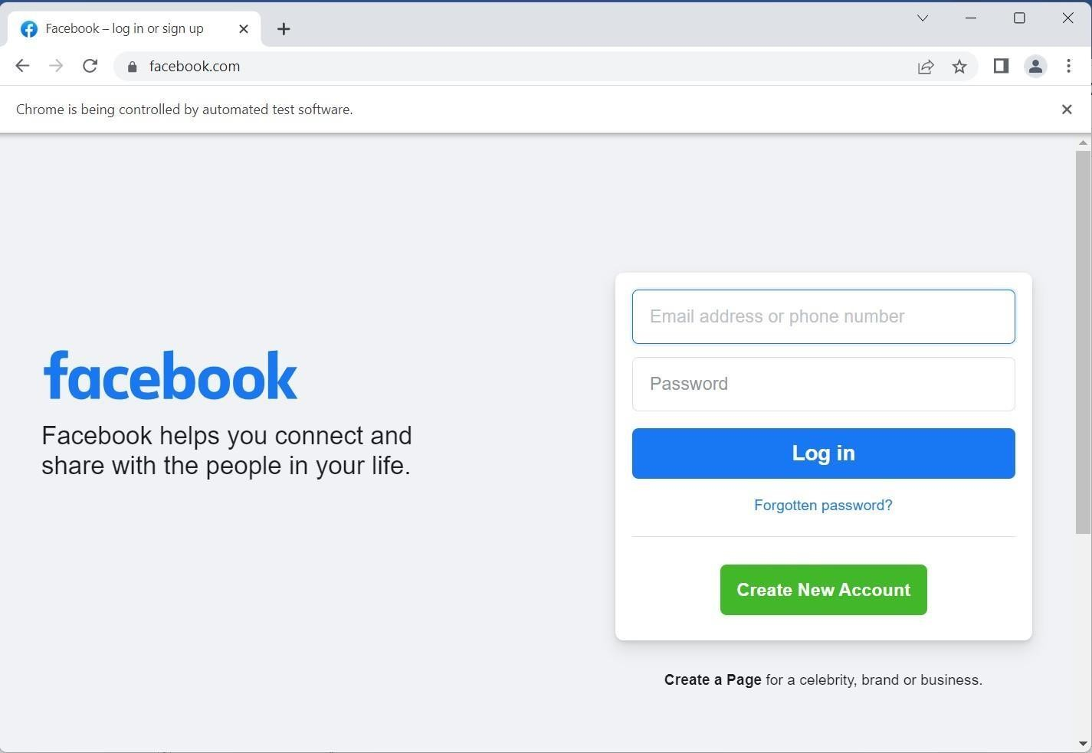

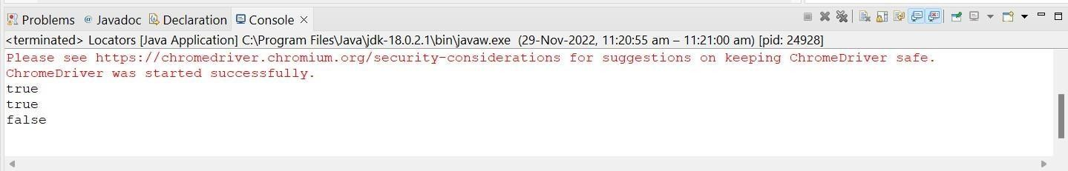

ID Locator:

Code:

package TestCases;

import org.openqa.selenium.By;

import org.openqa.selenium.WebDriver; import org.openqa.selenium.WebElement;

import org.openqa.selenium.chrome.ChromeDriver;

public class Locators {

public static void main(String[] args) { System.setProperty("Webdriver.chrome.driver","C:\\Users\\rushi\\On eDrive\\Desktop\\C21134_STQA

\\chromedriver.exe");

WebDriver driver = new ChromeDriver(); driver.get("https://[www.facebook.com/"](http://www.facebook.com/));

String title = driver.getTitle(); System.out.println("Title is: " + title); System.out.println("driver"+driver.getCurrentUrl());

WebElement unm= driver.findElement(By.id("email")); System.out.println(unm.getAttribute("id"));

System.out.println(unm.getTagName()); //Html tag name is ID

}

}

Output:

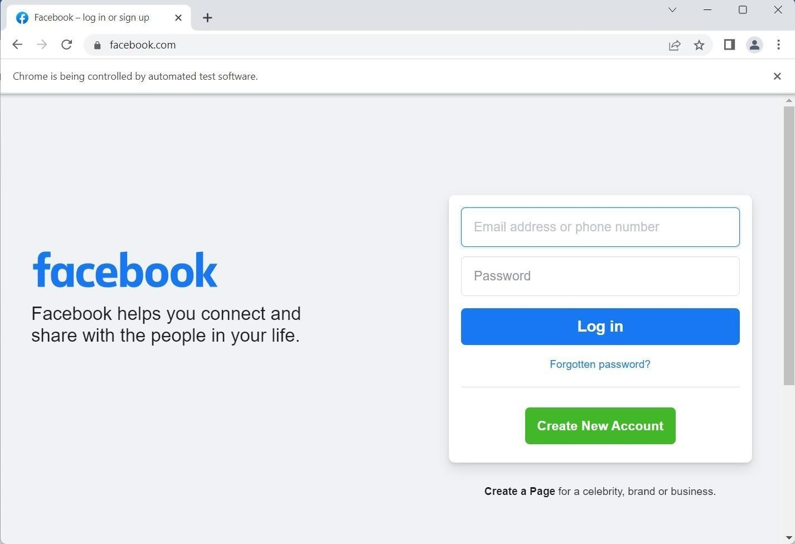

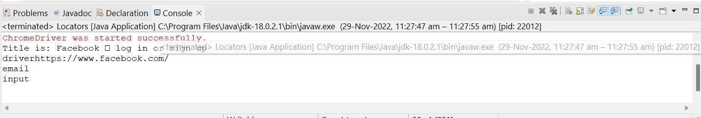

Locator By Using CSS Selector:

Code:

package TestCases;

import org.openqa.selenium.By;

import org.openqa.selenium.WebDriver; import org.openqa.selenium.WebElement;

import org.openqa.selenium.chrome.ChromeDriver;

public class Locators {

public static void main(String[] args) { System.setProperty("Webdriver.chrome.driver","C:\\Users\\rushi\\On eDrive\\Desktop\\C21134_STQA

\\chromedriver.exe");

WebDriver driver = new ChromeDriver(); driver.get("https://[www.facebook.com/"](http://www.facebook.com/));

WebElement el = driver.findElement(By.cssSelector("input[name='email']")); System.out.println(el.getTagName());

}

}

Output:



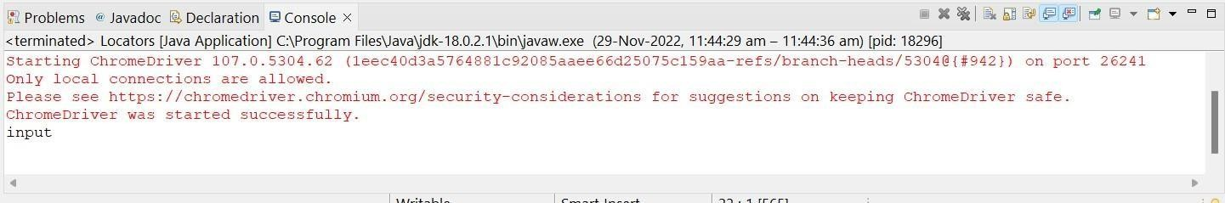

# Demonstrate different types of alerts

Code:

package TestCases;

import org.openqa.selenium.Alert; import org.openqa.selenium.By;

import org.openqa.selenium.WebDriver;

import org.openqa.selenium.chrome.ChromeDriver; import org.openqa.selenium.firefox.FirefoxDriver; public class Alerts {

public static void main(String[] args) { System.setProperty("Webdriver.chrome.driver","C:\\Users\\rushi\\On eDrive\\Desktop\\C21134_STQA

\\chromedriver.exe");

WebDriver driver = new FirefoxDriver();

//driver.get("https://[www.google.com](http://www.google.com/)"); driver.navigate().to("https://demo.guru99.com/test/delete_customer.p hp"); driver.findElement(By.name("cusid")).sendKeys("35"); driver.findElement(By.name("submit")).click();

Alert alt = driver.switchTo().alert();

String alert_msg = driver.switchTo().alert().getText(); System.out.println(alert_msg);

try { Thread.sleep(500);

} catch (InterruptedException e) {

// TODO Auto-generated catch block e.printStackTrace();

}

alt.accept();

System.out.println("Alert Box done");

}

}

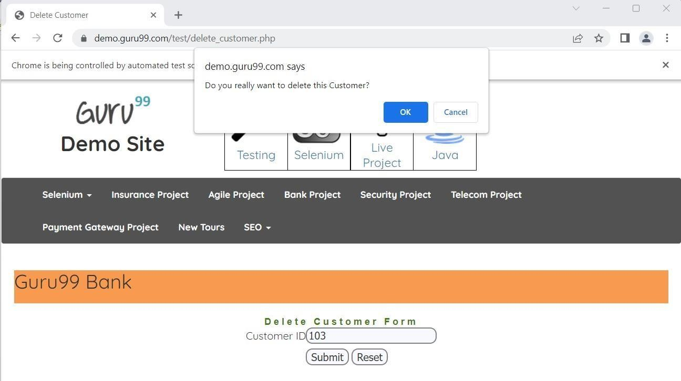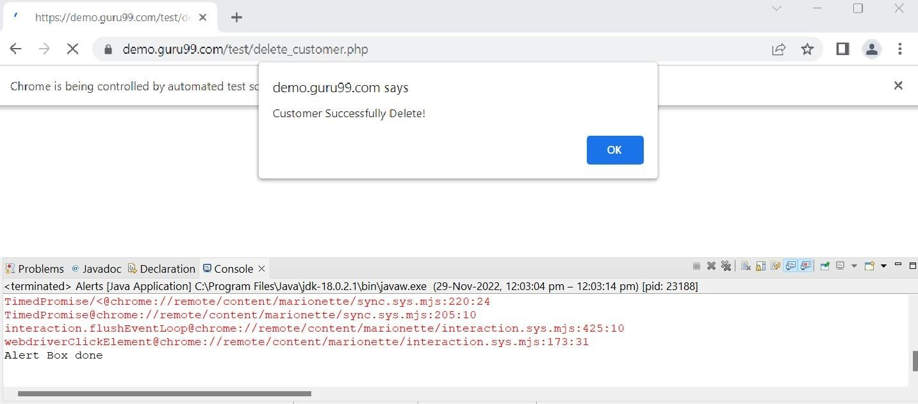**Output:**

1. **Demonstrate:**

# Handling Drop Down

Code:

package TestCases;

import org.openqa.selenium.By;

import org.openqa.selenium.WebDriver;

import org.openqa.selenium.chrome.ChromeDriver; import org.openqa.selenium.support.ui.Select; public class Drop_Down {

public static void main(String[] args) { System.setProperty("Webdriver.chrome.driver","C:\\Users\\rushi\\On eDrive\\Desktop\\C21134_STQA

\\chromedriver.exe");

WebDriver driver = new ChromeDriver();

//driver.get("https://[www.google.com](http://www.google.com/)"); driver.navigate().to("https://[www.facebook.com/r.php?r=101](http://www.facebook.com/r.php?r=101)"); Select month= new Select(driver.findElement(By.id("month")));

//month.deselectByVisibleText("Oct"); month.selectByIndex(2);

}

}

Output:

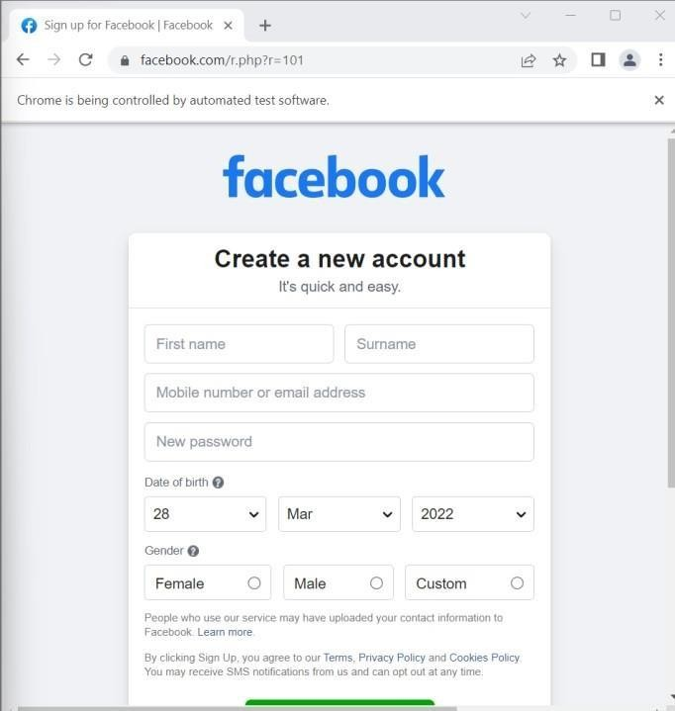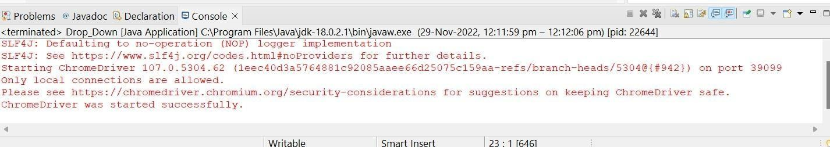

# List Boxes Code:

package TestCases; import java.util.List;

import org.openqa.selenium.By;

import org.openqa.selenium.WebDriver; import org.openqa.selenium.WebElement;

import org.openqa.selenium.chrome.ChromeDriver; import org.openqa.selenium.support.ui.Select;

public class Drop_Down {

public static void main(String[] args) { System.setProperty("Webdriver.chrome.driver","C:\\Users\\rushi\\On eDrive\\Desktop\\C21134_STQA

\\chromedriver.exe");

WebDriver driver = new ChromeDriver();

//driver.get("https://[www.google.com](http://www.google.com/)"); driver.navigate().to("https://[www.facebook.com/r.php?r=101](http://www.facebook.com/r.php?r=101)"); Select month= new Select(driver.findElement(By.id("month"))); List

<WebElement> gender = driver.findElements(By.name("sex")); int cnt = gender.size();

System.out.println(cnt);

for(int i=0;i<=cnt-1;i++)

{

String text = gender.get(i).getText(); System.out.println(text); gender.get(i).click();

try { Thread.sleep(200);

} catch (InterruptedException e) {

// TODO Auto-generated catch block e.printStackTrace();

}

}

}

}

**Output:**

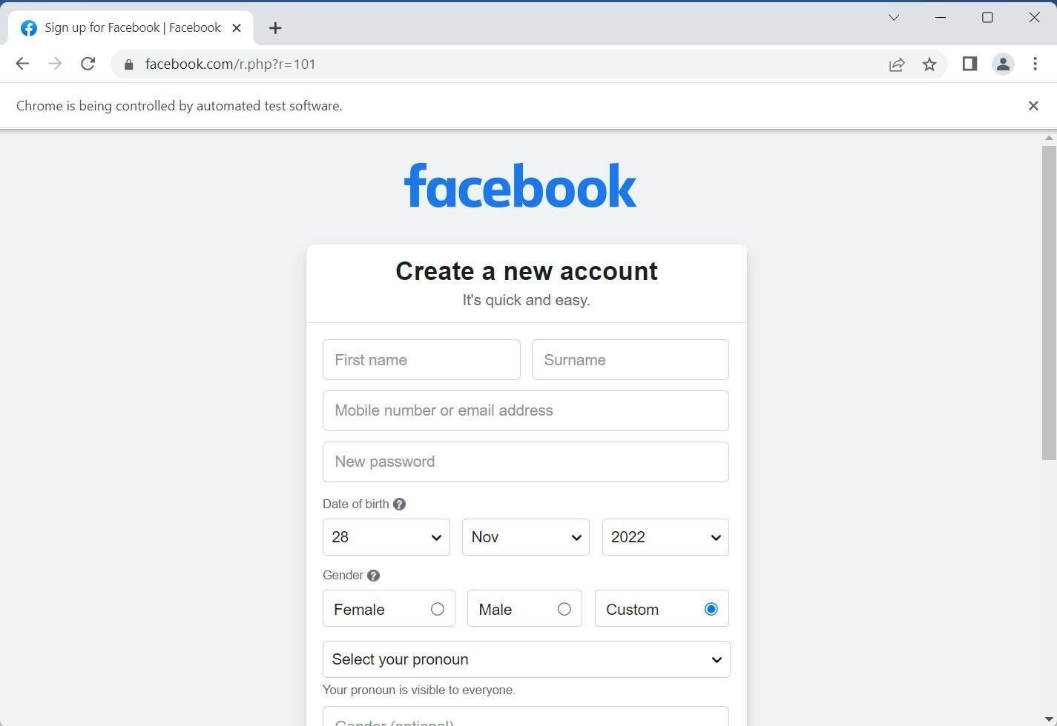

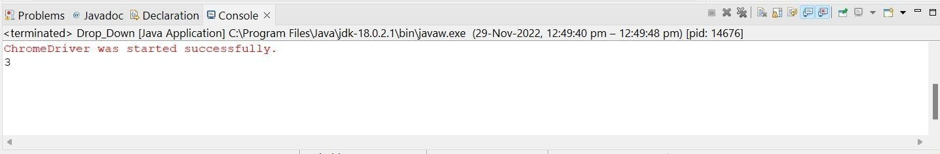

**Command Button**

Get Title:

package TestCase;

import org.openqa.selenium.WebDriver;

import org.openqa.selenium.chrome.ChromeDriver; public class Command_Button {

public static void main(String[] args) { System.setProperty("Webdriver.chrome.driver","C:\\Users\\rushi\\On eDrive\\Desktop\\C21134_STQA

\\chromedriver.exe");

WebDriver driver = new ChromeDriver(); driver.get("https://[www.google.com/](http://www.google.com/)"); String title = driver.getTitle(); System.out.println("Title is: "+title); System.out.println(driver.getTitle());

}

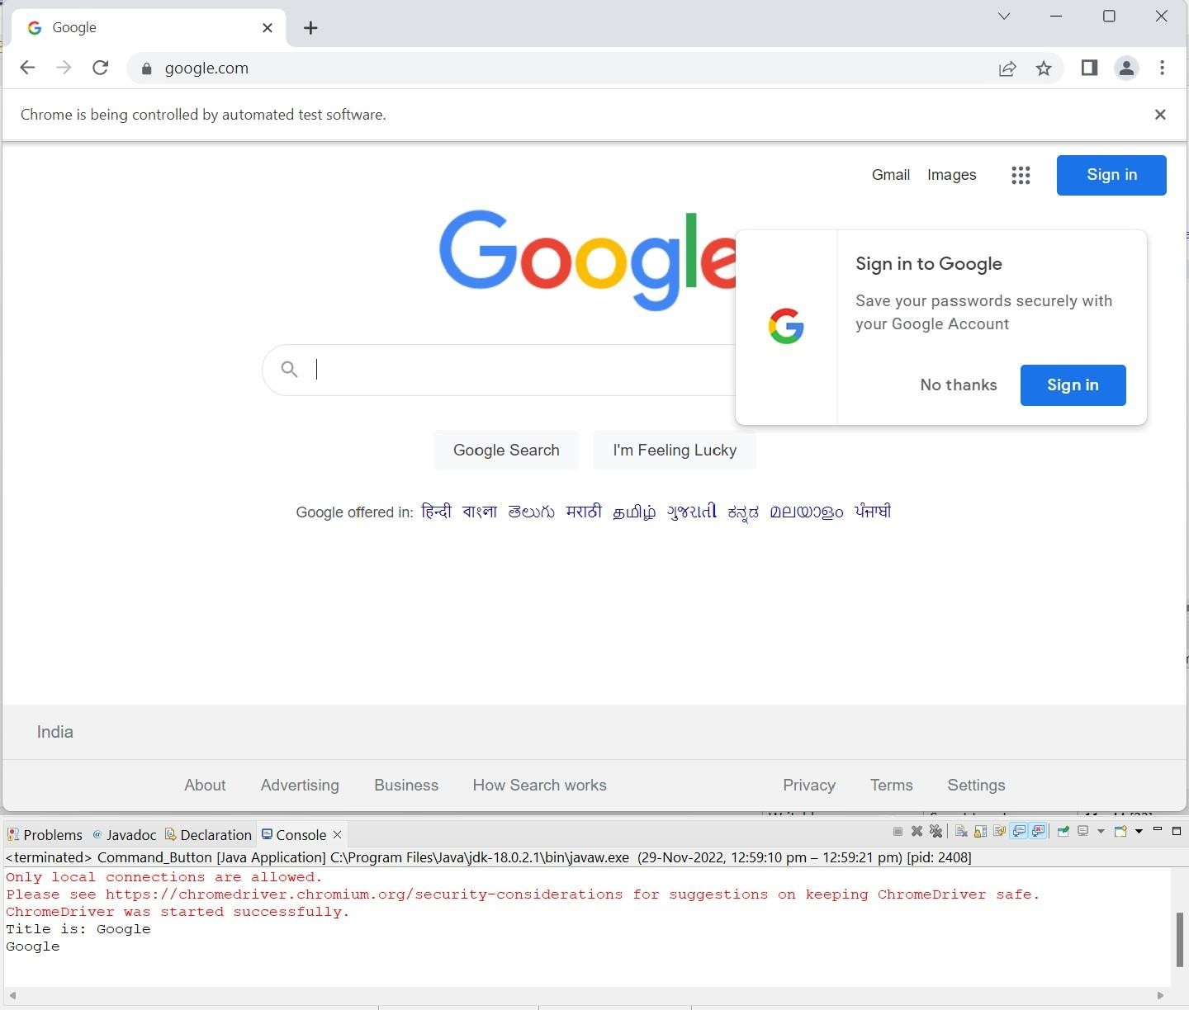

# Radio buttons & text boxes

First, we Create the html file:

<!DOCTYPE html>

<html lang="en">

<head>

<meta charset="UTF-8">

<meta http-equiv="X-UA-Compatible" content="IE=edge">

<meta name="viewport" content="width=device-width, initial- scale=1.0">

<title>Document</title>

</head>

<body>

<h1>Html page</h1>

<input type="radio" name="course" value="MCA">MCA</br></br>

<input type="radio" name="course" value="MMS">MMS</br></br>

<input type="radio" name="course" value="BCA">BCA</br></br>

</body>

</html>

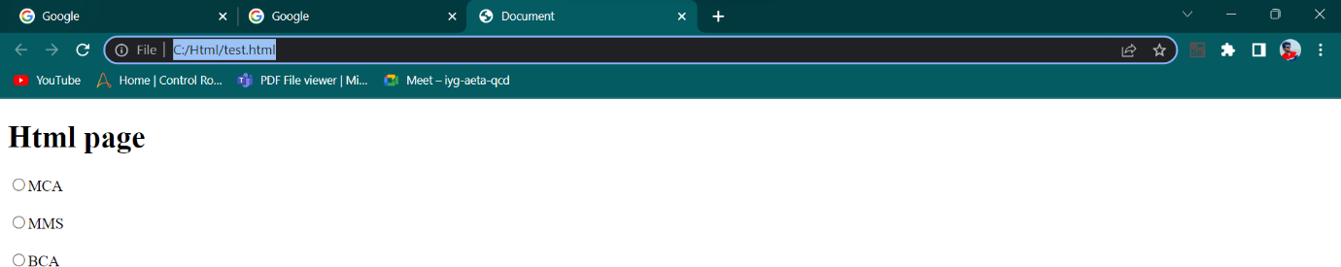

Code:

package TestCases;

import org.openqa.selenium.By;

import org.openqa.selenium.WebDriver;

import org.openqa.selenium.chrome.ChromeDriver; public class Radio_Button {

public static void main(String[] args) { System.setProperty("Webdriver.chrome.driver","C:\\Users\\rushi\\On eDrive\\Desktop\\C21134_STQA

\\chromedriver.exe");

WebDriver driver = new ChromeDriver();

//driver.get("https://[www.google.com](http://www.google.com/)"); driver.navigate().to("file:///C:/Html/test.html"); driver.findElement(By.xpath("/html/body/input[3]")).click(); System.out.println("Sucessfully completed");

}

}

Output:

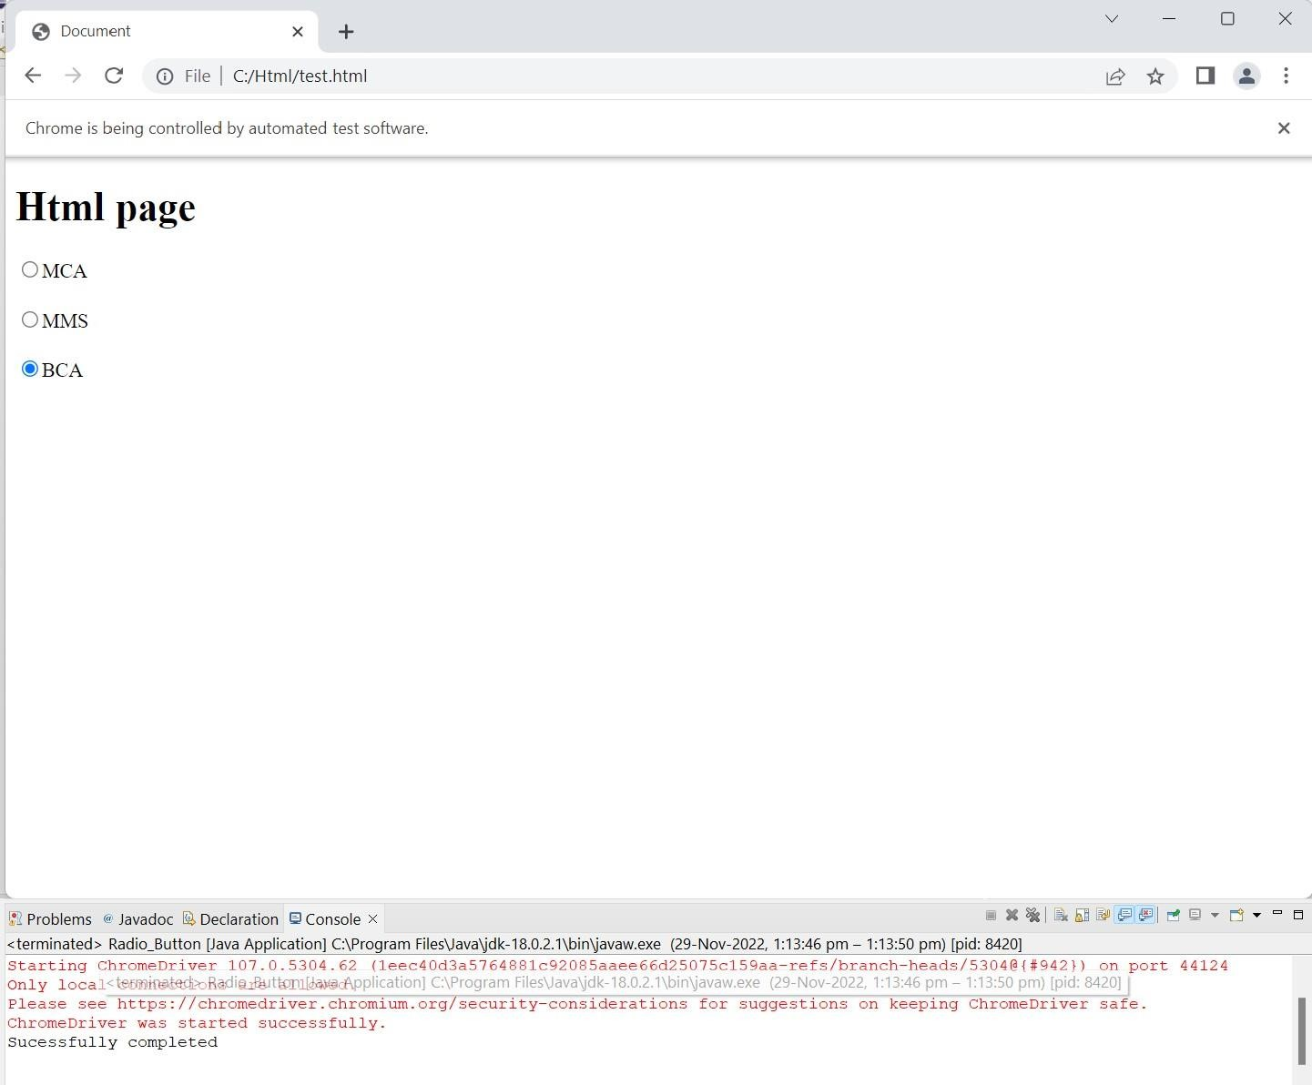

# Waits command in selenium

Thread.sleep() method use for wait command for the process. which we can see the process very easily.

Code:



# Installation of TestNG, Running TestNG:

TestNg

TestNG is an advance framework designed in a way to leverage the benefits by both the developers and testers.

TestNG is an automation testing framework in which NG stands for “Next Generation”. TestNG is inspired by [JUnit](https://www.guru99.com/junit-tutorial.html) which uses the annotations (@). TestNG overcomes the disadvantages of JUnit and is designed to make [end-to-end testing](https://www.guru99.com/end-to-end-testing.html) easy.

Using TestNG, you can generate a proper report, and you can easily come to know how many test cases are passed, failed, and skipped. You can execute the failed test cases separately.

For example:

Suppose, you have five test cases, one method is written for each test case (Assume that the program is written using the main method without using testNG). When you run this program first, three methods are executed successfully, and the fourth method is failed.

Then correct the errors present in the fourth method, now you want to run only fourth method because first three methods are anyway executed successfully. This is not possible without using TestNG.

The TestNG in Selenium provides an option, i.e., testng-failed.xml file in test-output folder. If you want to run only failed test cases means you run this XML file. It will execute only failed test cases.

Installation

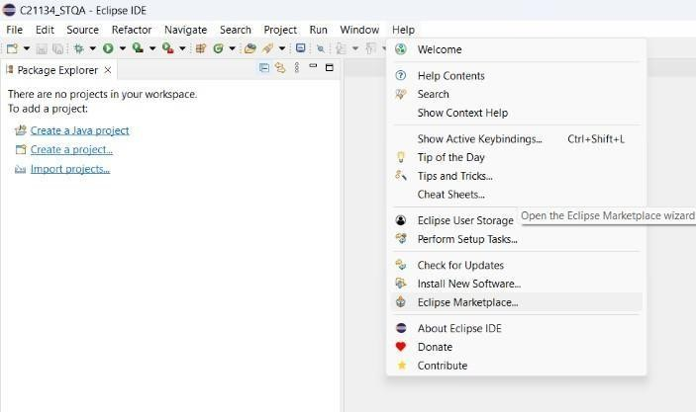

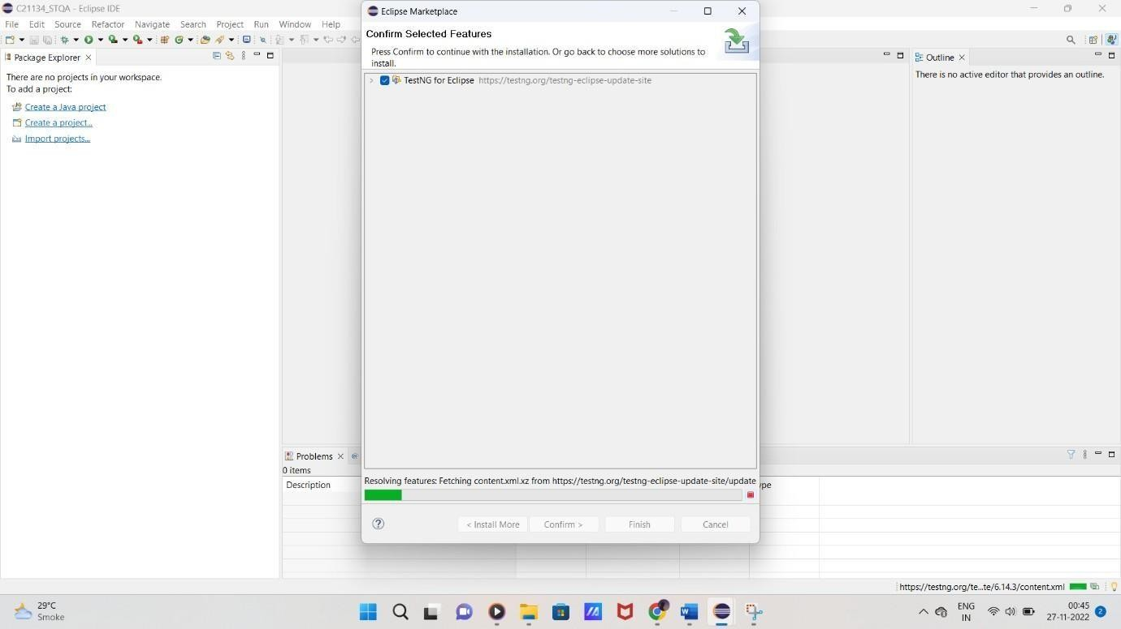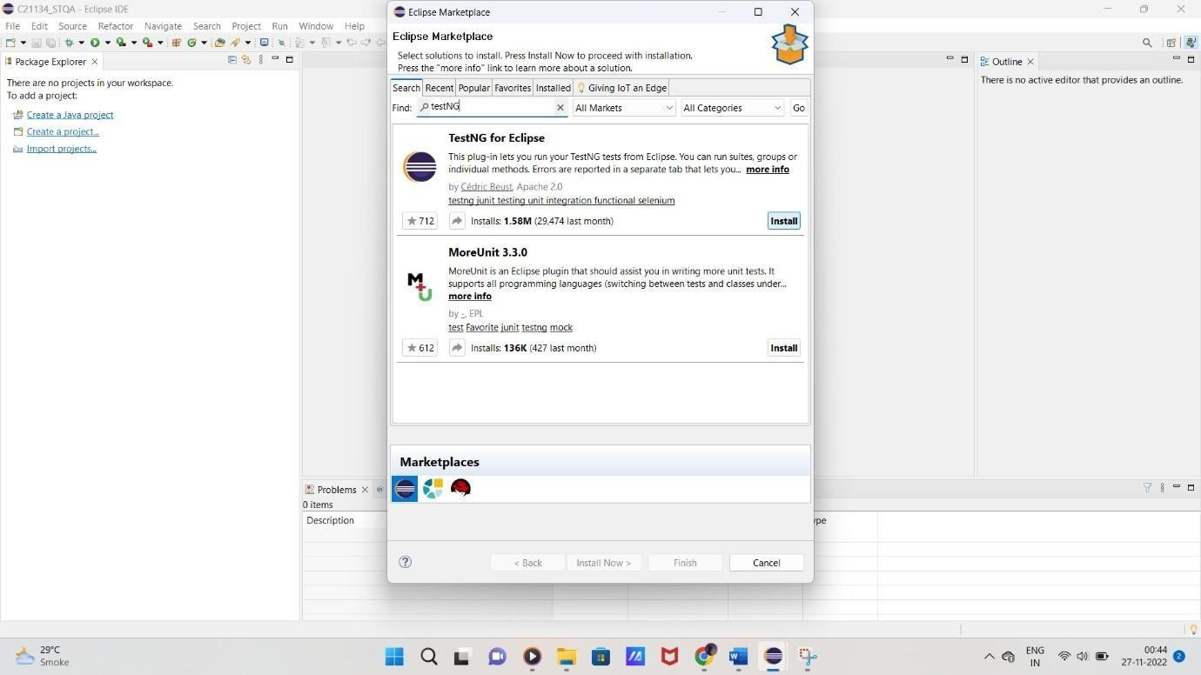

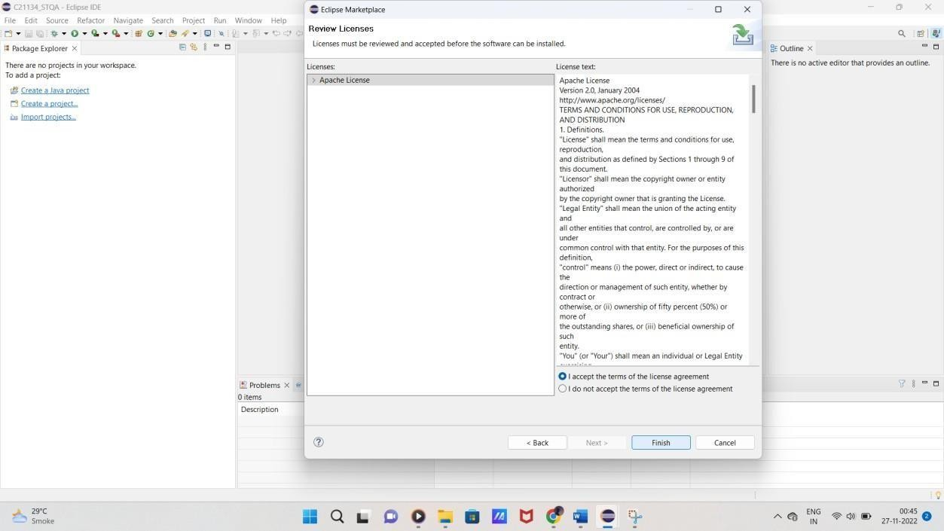

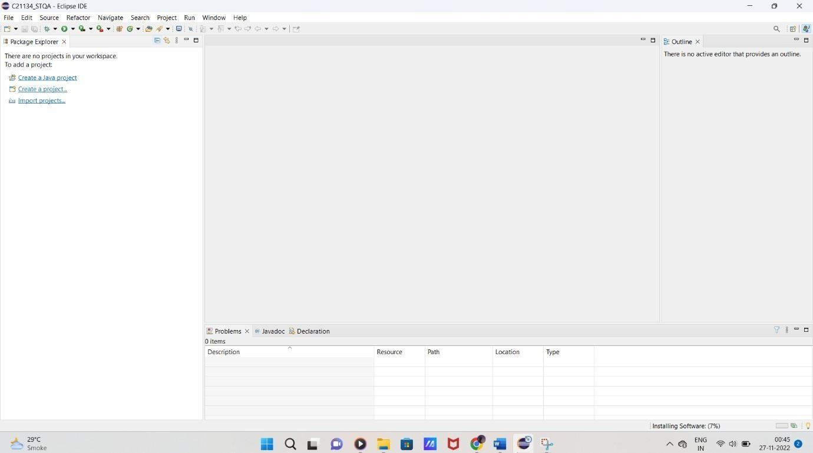

Step 5) After accept the licence agreement, wait for installation. ignore security warning if occurs

If you encounter a Security warning, just click “Install Anyway”. Or select all trust issues

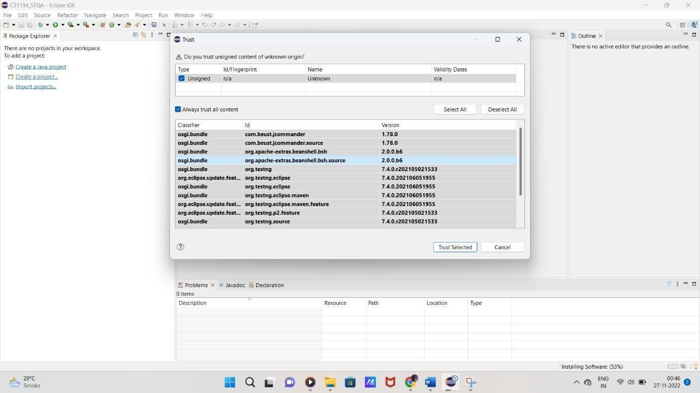

Finish the installation and restart your system

Wait for the TestNG install in Eclipse to finish. When Eclipse prompts you for a restart, click “Restart now.”

Verify if the installation is done properly

After the restart, verify if TestNG for Eclipse was indeed successfully installed. Click Window > Show View > Other.

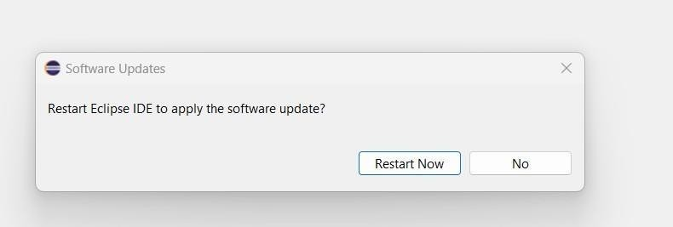

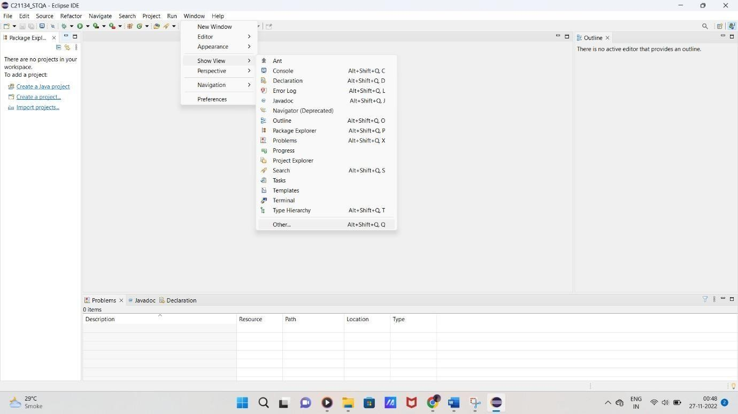

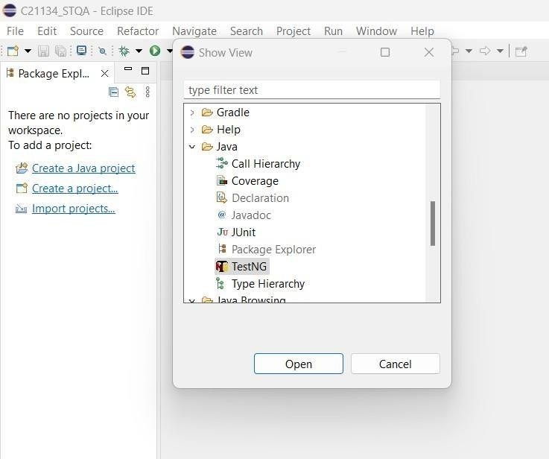

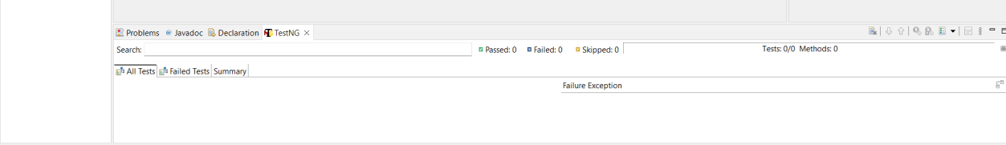Click on open and that’s it..Now see the changes in console.. It has opened Test NG Terminal also

# Running TestNG Annotations:

TestNG1.java:

package TestNGFrameworkDemo; import org.openqa.selenium.By; import org.openqa.selenium.Keys;

import org.openqa.selenium.WebDriver;

import org.openqa.selenium.chrome.ChromeDriver; import org.testng.annotations.Test;

public class TestNG1 {

public String baseUrl = "https://[www.google.com/"](http://www.google.com/);

String driverPath = "E:\\C21134 Hrushikesh\\chromedriver\\chromedriver.exe";

public WebDriver driver; @Test

public void f() throws InterruptedException { System.out.println("Launching chrome browser"); System.setProperty("Webdriver.chrome.driver", driverPath); driver = new ChromeDriver();

driver.get(baseUrl);

driver.findElement(By.name("q")).sendKeys("DES NMITD", Keys.ENTER); Thread.sleep(2000);

}

}

TestNG2.java:

package TestNGFrameworkDemo; import org.openqa.selenium.By; import org.openqa.selenium.Keys;

import org.openqa.selenium.WebDriver;

import org.openqa.selenium.chrome.ChromeDriver; import org.testng.annotations.Test;

public class TestNG2 { @Test

public void TestGoogle() throws InterruptedException { System.setProperty("webdriver.chrome.driver", "E:\\C21134

Hrushikesh\\chromedriver\\chromedriver.exe");

WebDriver driver = new ChromeDriver(); driver.get("https://[www.google.co.in/"](http://www.google.co.in/)); driver.findElement(By.name("q")).sendKeys("DES's NMITD",Keys.ENTER); Thread.sleep(2000);

}

@Test

public void TestFacebook() throws InterruptedException { System.setProperty("webdriver.chrome.driver", "E:\\C21134

Hrushikesh\\chromedriver\\chromedriver.exe");

WebDriver driver = new ChromeDriver(); driver.get("https://[www.facebook.com/"](http://www.facebook.com/)); driver.findElement(By.name("email")).sendKeys("DES's NMITD",Keys.ENTER); Thread.sleep(2000);

}

}

Output:

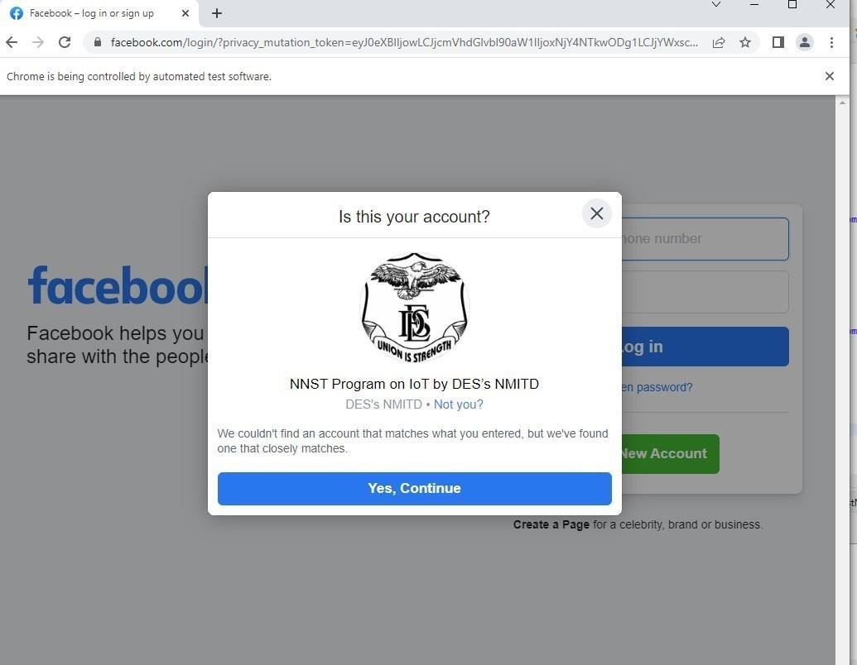

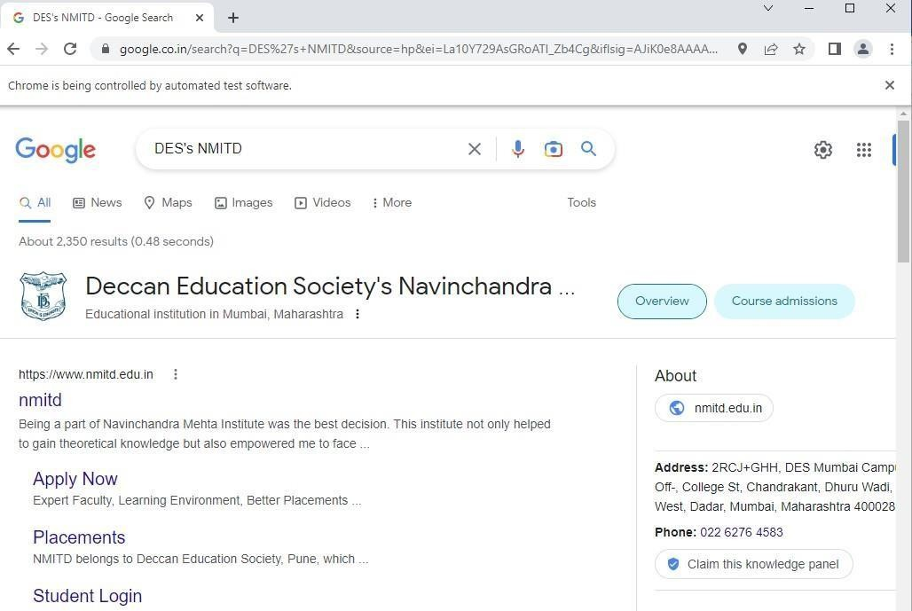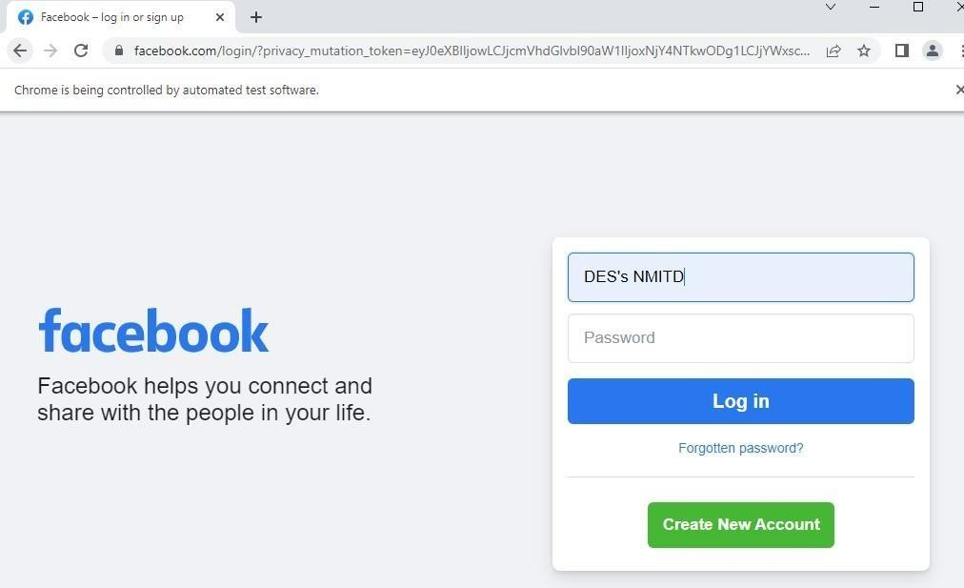

package TestNGFrameworkDemo; import org.testng.annotations.Test; import org.openqa.selenium.WebDriver;

import org.openqa.selenium.chrome.ChromeDriver; import org.testng.annotations.BeforeTest;

import org.openqa.selenium.WebDriver;

import org.openqa.selenium.chrome.ChromeDriver; import org.testng.Assert;

import org.testng.annotations.AfterTest; public class TestNG3 {

String actualTitle,expectedTitle; @BeforeTest public void launchBrowser() {

System.out.println("launching Google chrome browser"); System.setProperty("webdriver.chrome.driver", "E:\\C21134

Hrushikesh\\chromedriver\\chromedriver.exe");

WebDriver driver = new ChromeDriver(); driver.get("https://demo.guru99.com/test/newtours/");

}

@Test

public void verifyHomepageTitle() {

String expectedTitle = "Welcome: Mercury Tours"; String ActualTitle

= driver.getTitle(); Assert.assertEquals(actualTitle, expectedTitle);

}

@AfterTest

public void terminateBrowser() { driver.close();

}

}

**Output:**

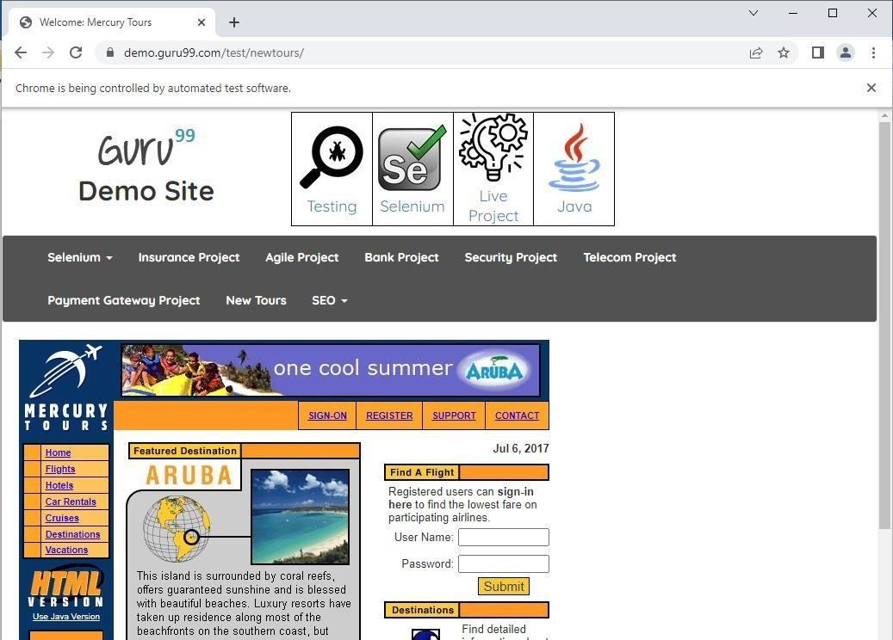

1. **Demonstrate Validation testing**

Code:

package TestCases;

import org.openqa.selenium.By;

import org.openqa.selenium.WebDriver;

import org.openqa.selenium.chrome.ChromeDriver; public class Validations_Test {

public static void main(String []args)

{

System.setProperty("Webdriver.chrome.driver","C:\\STQA\\Drivers\\ chromedriver.exe"); WebDriver driver = new ChromeDriver();

driver.get("https://[www.google.com/"](http://www.google.com/));

String title =driver.getTitle(); // Check the validation of title System.out.println("title is" +title); System.out.println(driver.getCurrentUrl()); //Check the validation of URL

// # Check the validation of the Search box is Visible are not. boolean status =

driver.findElement(By.xpath("/html/body/div[1]/div[3]/form/div[1]/di v[1]/div[1]")).isDisplayed();

if(status){

System.out.println("Search box is visible");

} else {

}

}

}

Output:

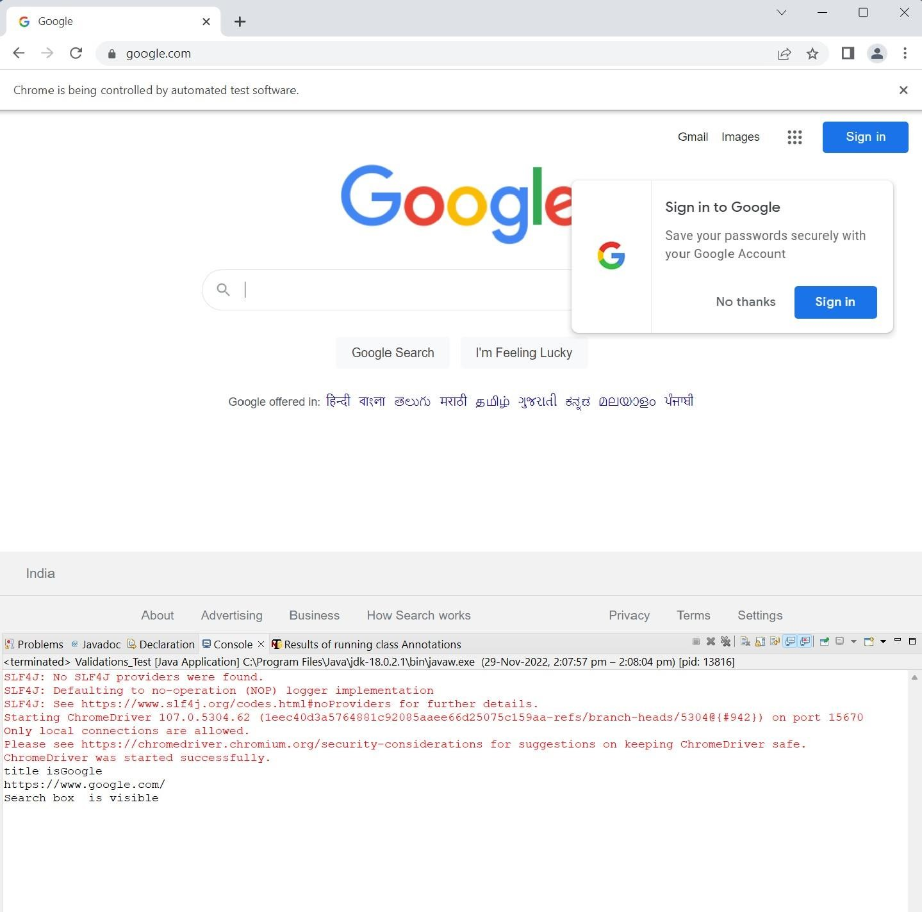

# Perform regression testing

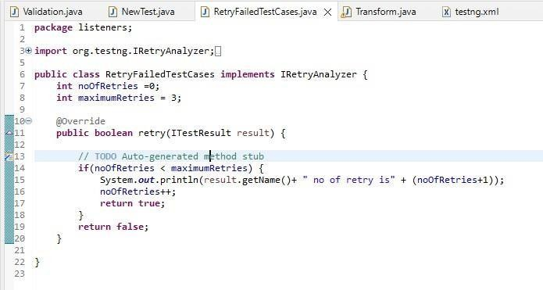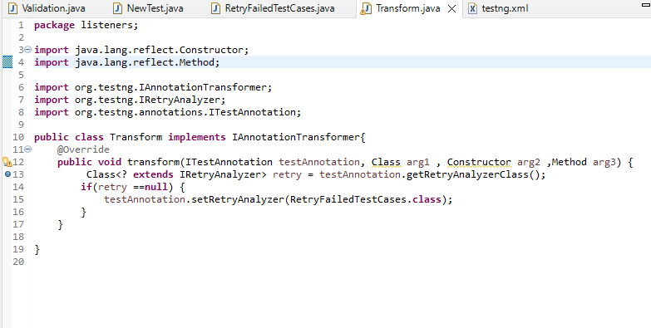Retrying failed test cases using listeners in TestNG. Code:

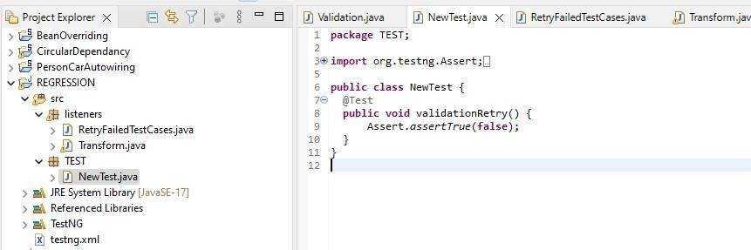

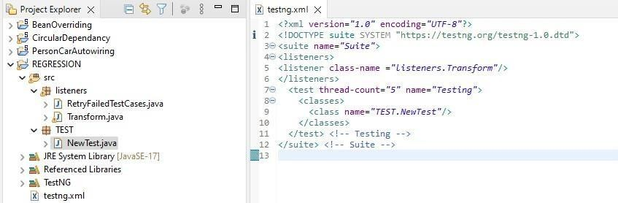

**Output:**

